ENROLL ONLINE

Date | Description | Author | Version
21/02/2016 | USER MANUAL FOR ENROLL ONLINE | SHAMLIKHAN CP | 1.0
RIVISION HISTORY

PROGRESS FLOW OF ENROLL ONLINE

ONLINe ENROLLMENT
- Select the Enroll Online option from side menu bar.

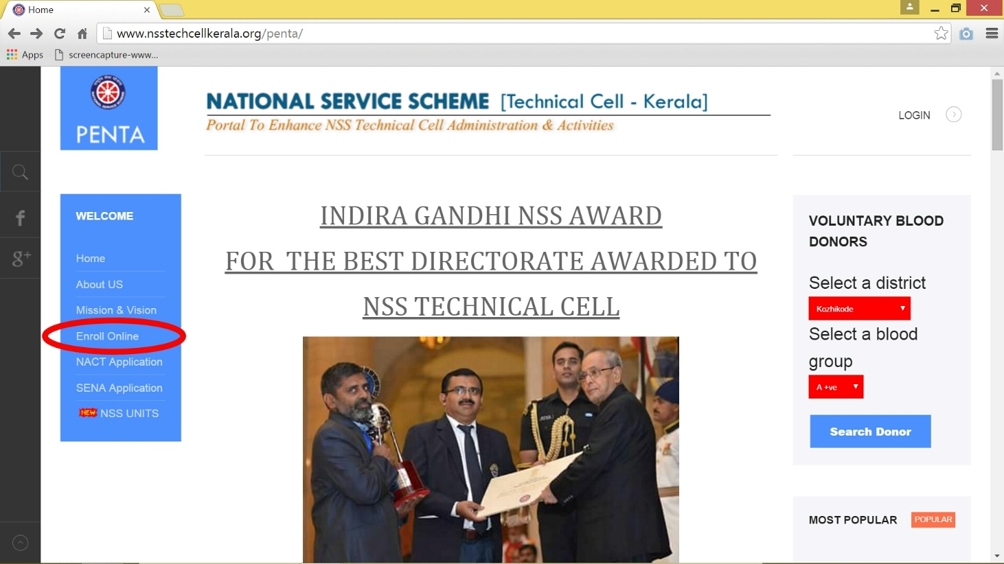

- You will be navigated to a webpage. Enter your unit number and click NEXT button.

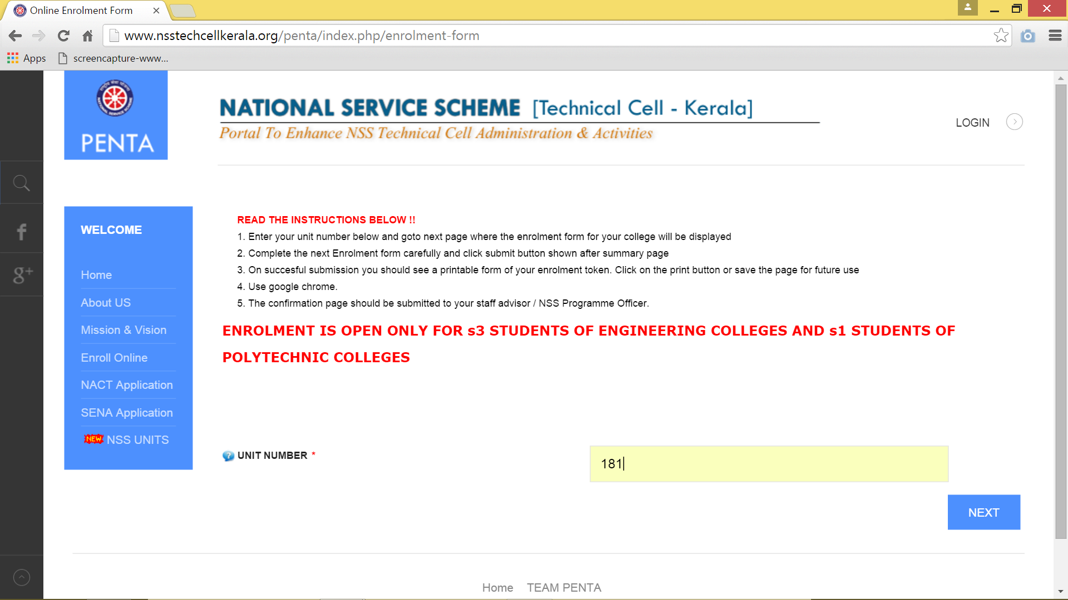

- Fill in the following details carefully. Fill the columns which are indicated by red star is mandatory. You should enter your Date of Birth in dd/mm/yyyy format and you should upload your photo in png format. Then click the NEXT button.
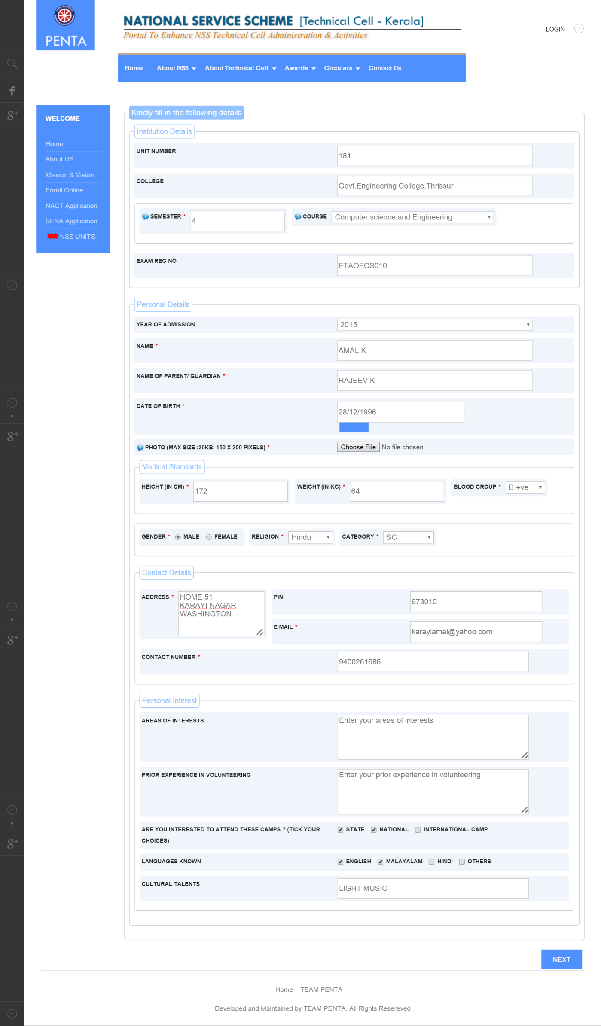
- Verify your details that you have given. Then click the SUBMIT button.

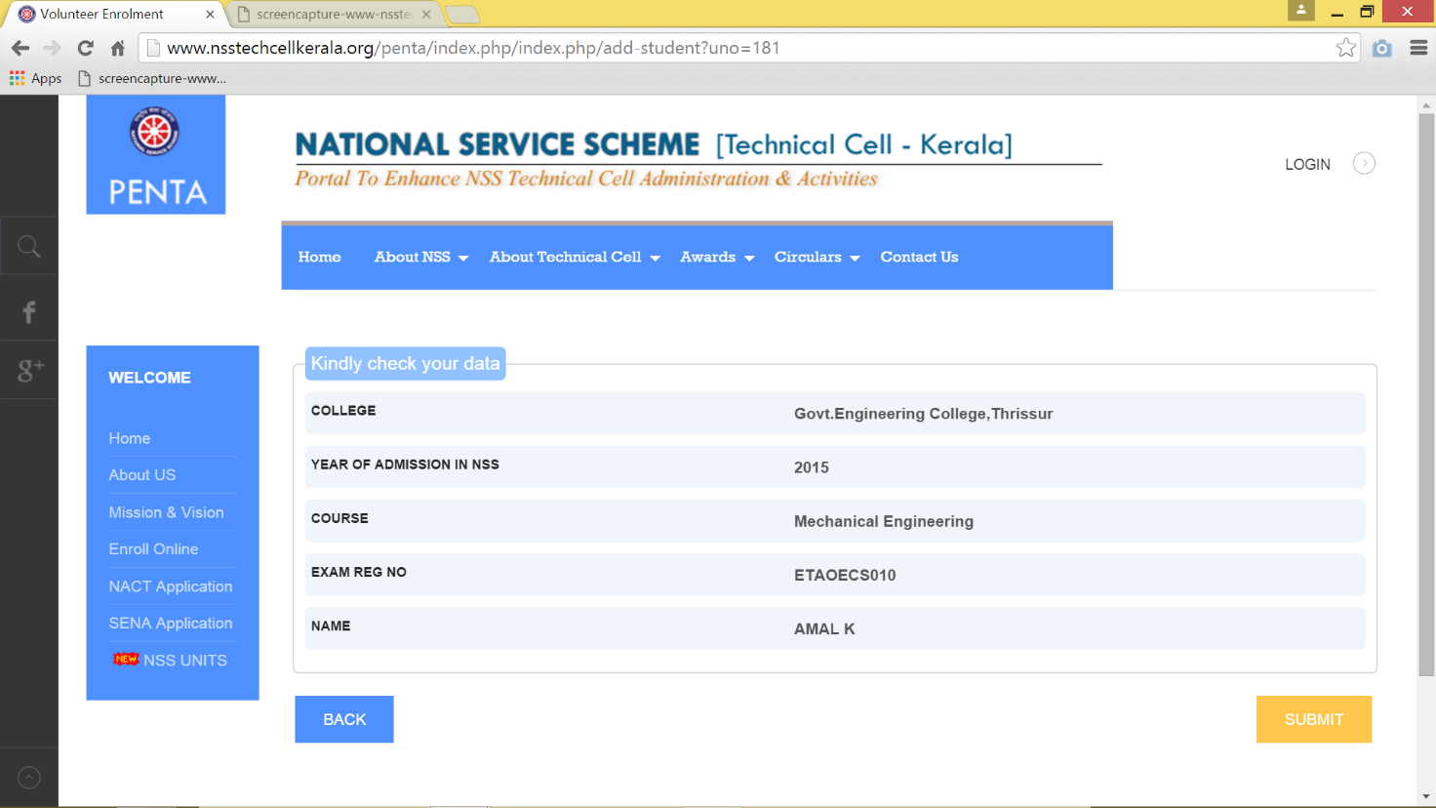

- Take a print out of the generated ENROLLMENT FORM and submit to your program officer for further proceedings.
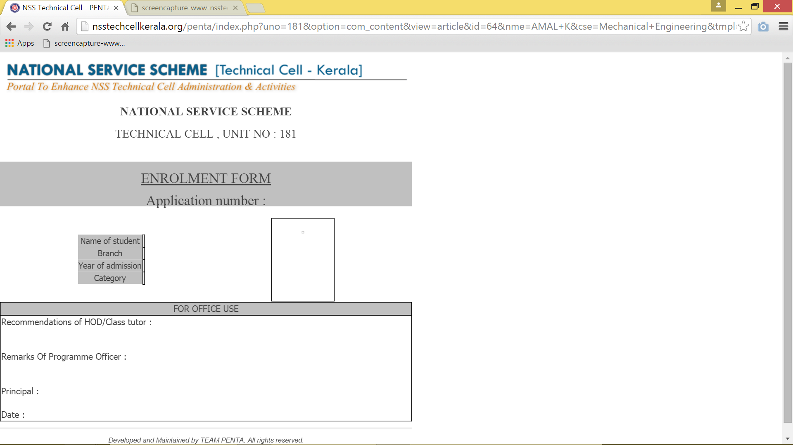

NOTE: You can take print out by pressing ctrl+p.

