EDIT SECRETARIES

REVISION HISTORY
Date | Description | Author | VERSION
21/02/16 | USER MANUAL FOR EDIT SECRETARIES |  | 1.0

PROGRESS FLOW OF EDIT SECRETARIES

LOGIN FOR PO
- Open Mozilla firefox/Google Chrome and type the address http://www.nsstechcellkerala.org/penta/ and press enter the following page will load.

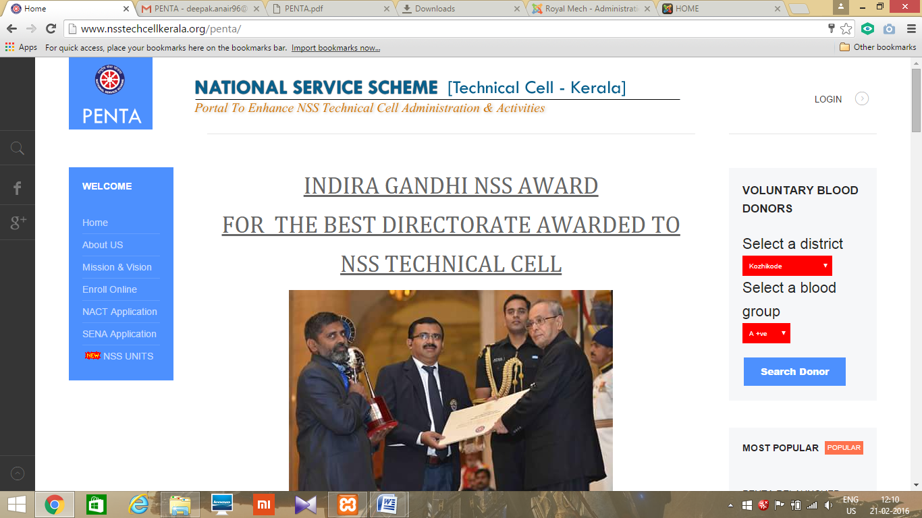

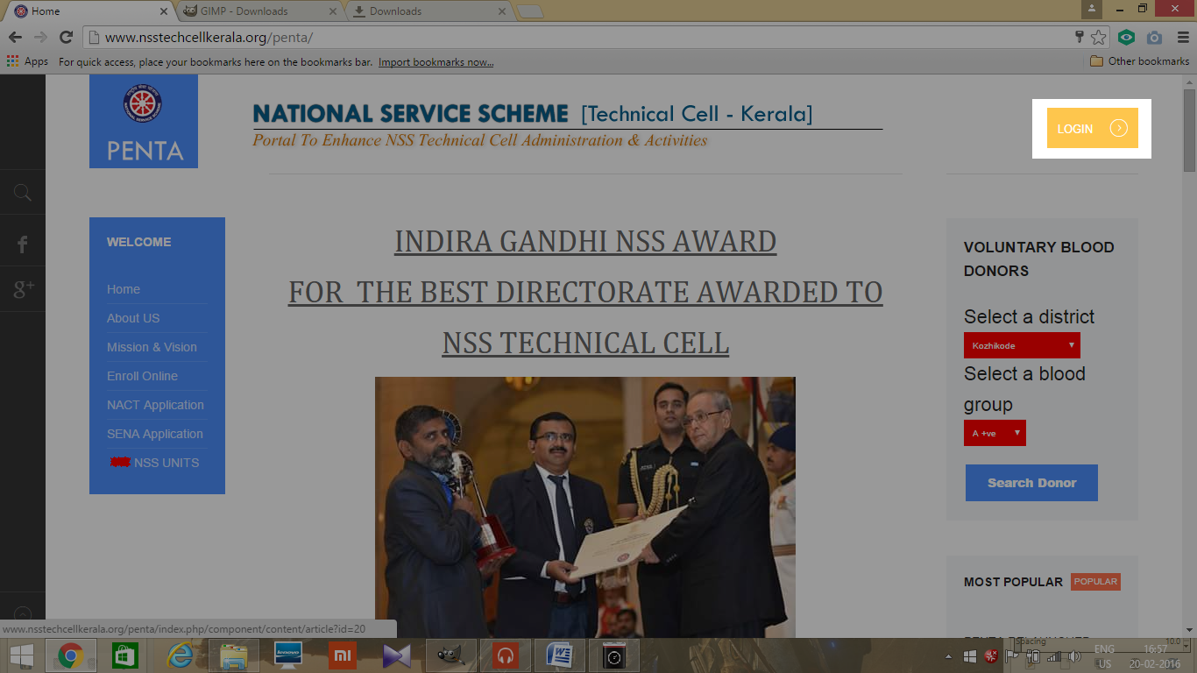
- Click LOGIN

- Then enter USERNAME and PASSWORD of PO and click login
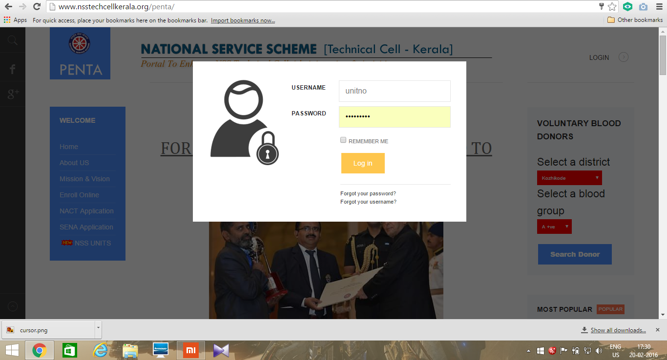

- Then the following dashboard will open
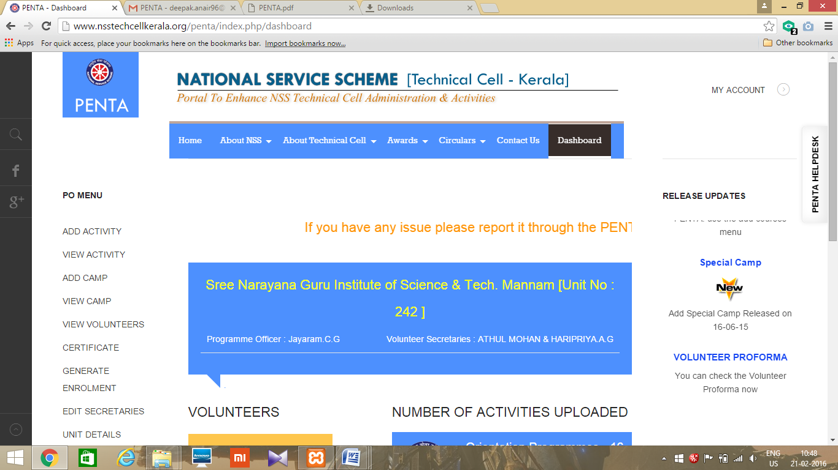

Edit secretaries

- After login, select the EDIT SECRETARIES option from side menu bar.

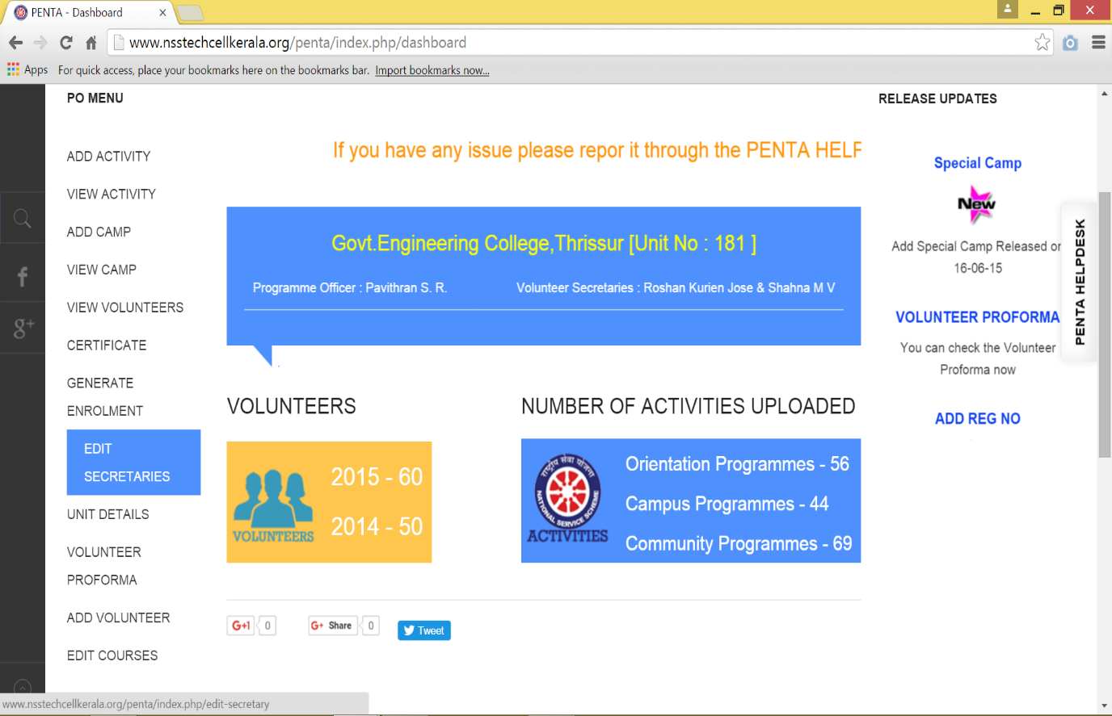

- You will be navigated to an editable webpage showing the details of the volunteer secretaries.

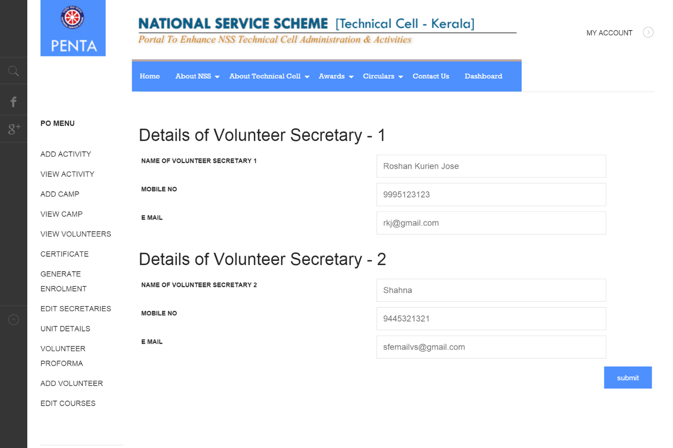
- A popup will be shown after successful submission.

LOGOUT
- Click MY ACCOUNT on the top right corner.
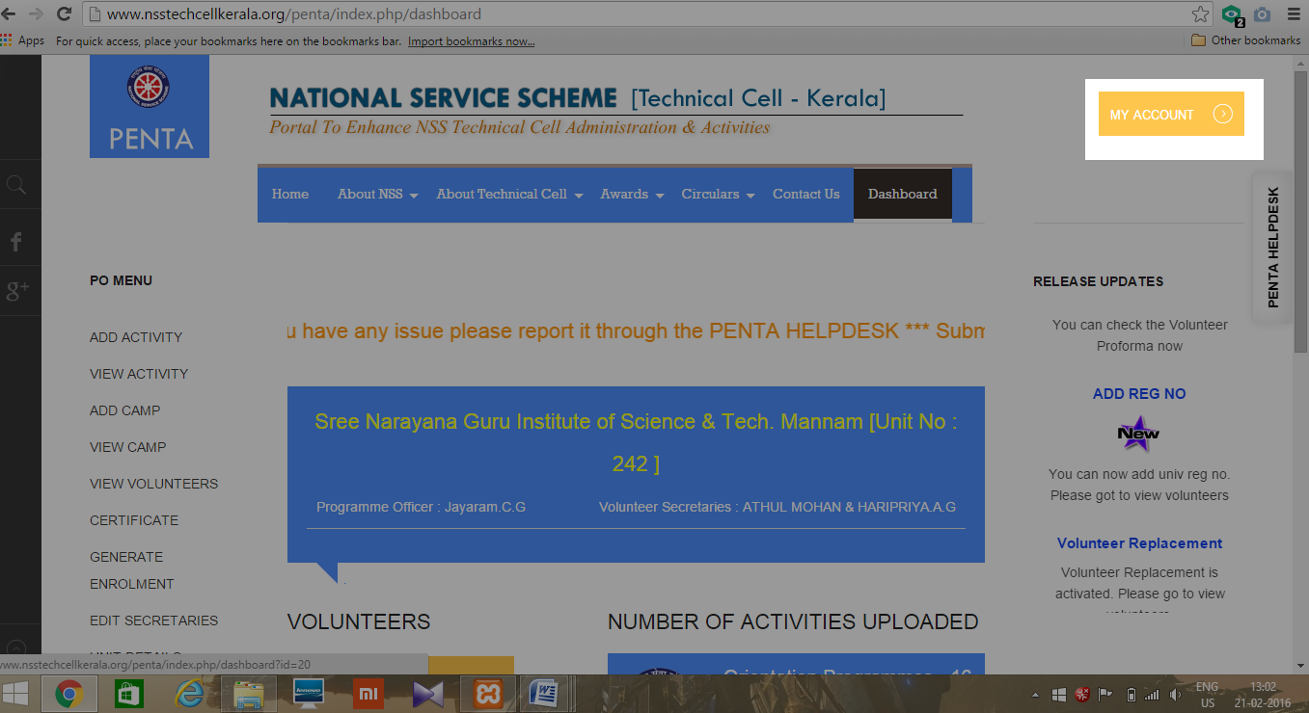
- Click LOGOUT
