VOLUNTEER PROFORMA

PROGRESS FLOW OF VOLUNTEER PROFORMA

REVISED HISTORY
Date | Description | Author | Version
21/02/2016 | USER MANUAL FOR VOLUNTEER PROFORMA | Ananthu.s | 1.0

LOGIN FOR PO
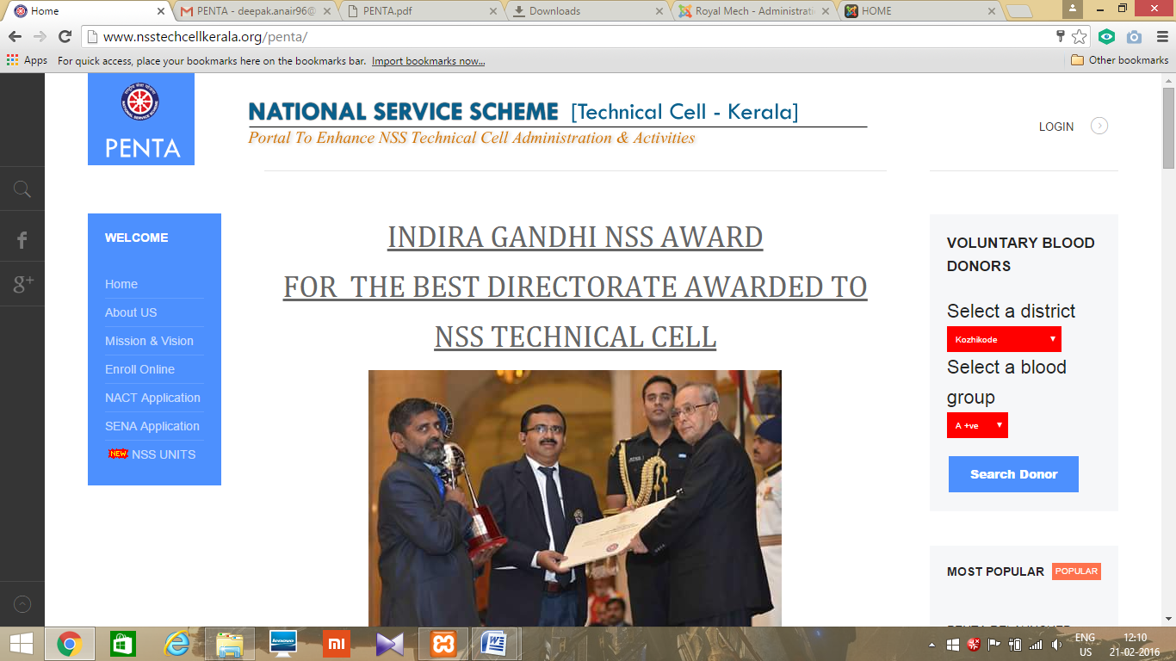
- Open Mozilla firefox/Google Chrome and type the address http://www.nsstechcellkerala.org/penta/ and press enter the following page will load.

- Click LOGIN
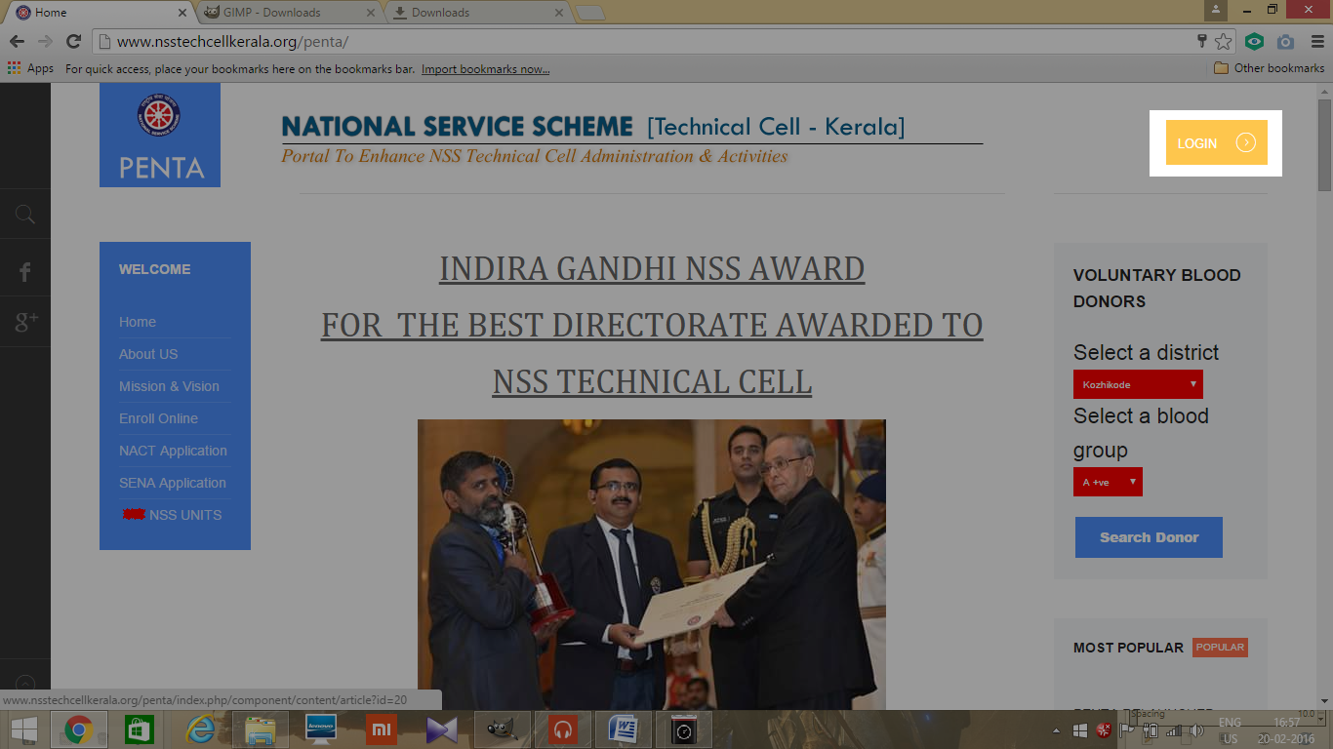
- Then enter USERNAME and PASSWORD of Programme officer
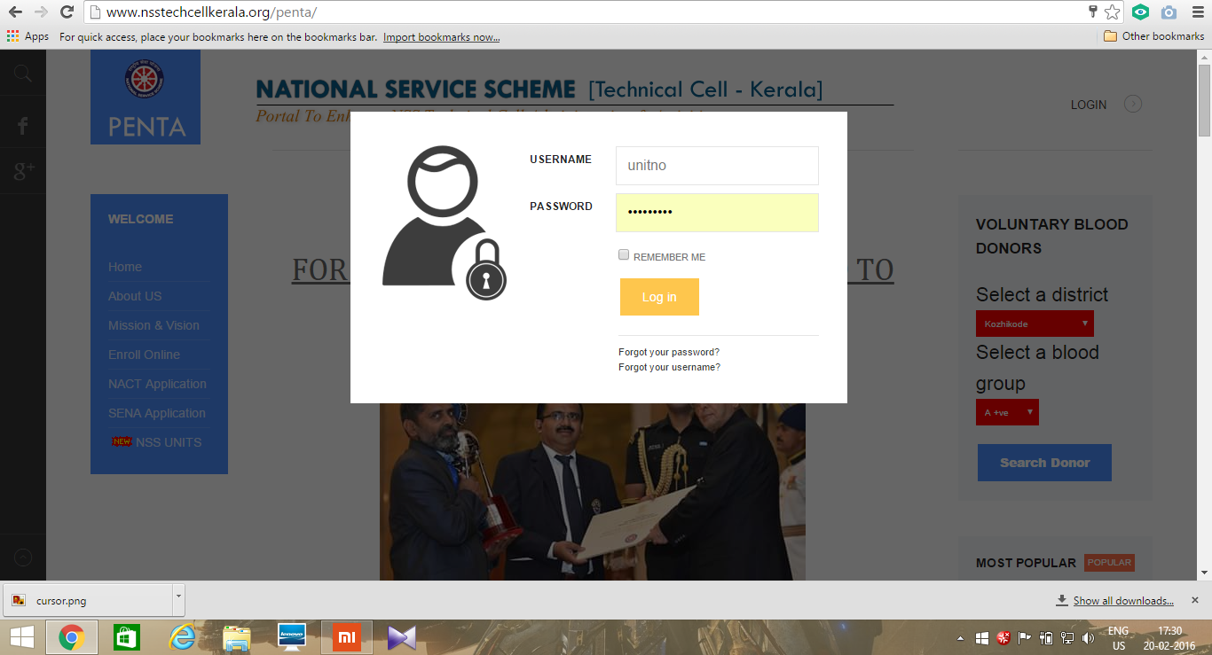

- Then the following dashboard will open
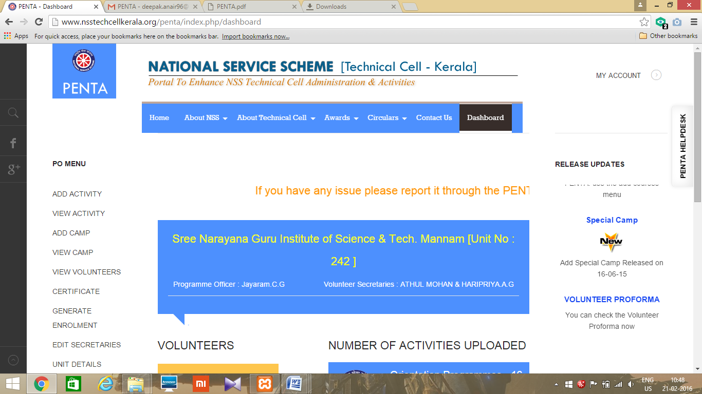

VOLUNTEER PROFORMA

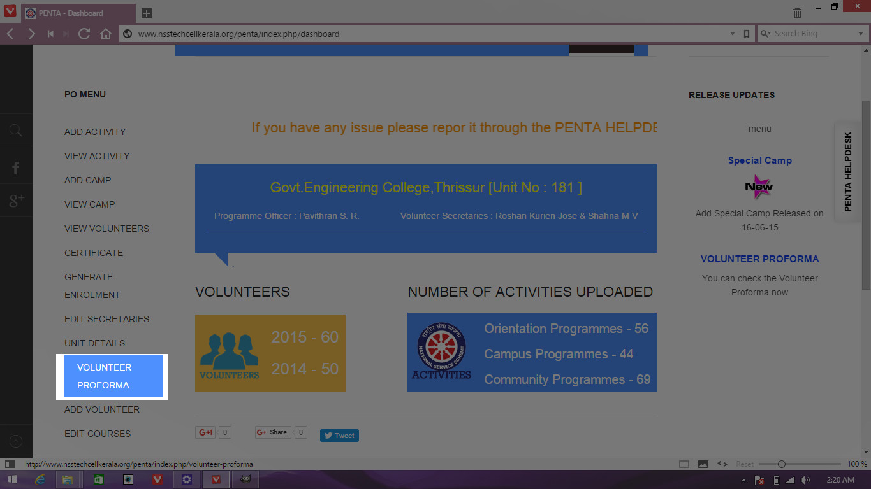
- After login, from the dashboard select the link VOLUNTEER PROFORMA
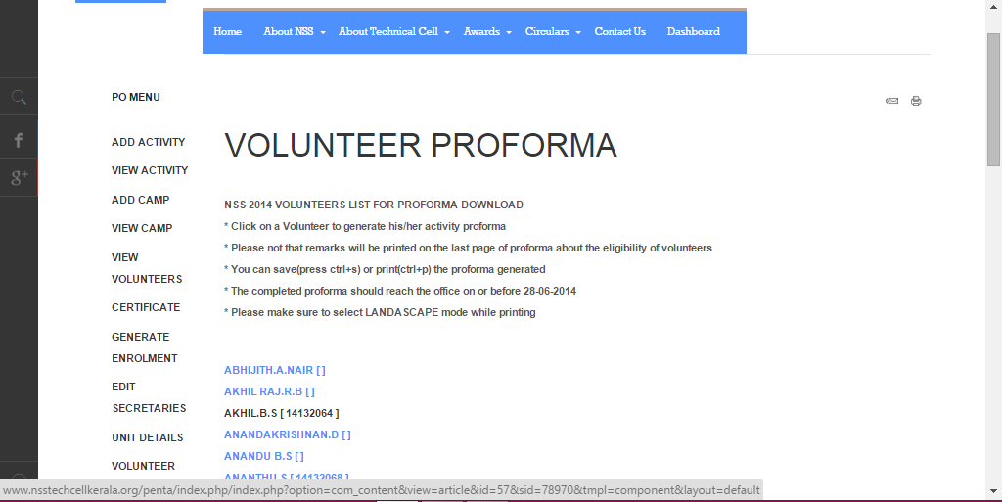
- Then appear a new page with the volunteer list who are completed the volunteership period.

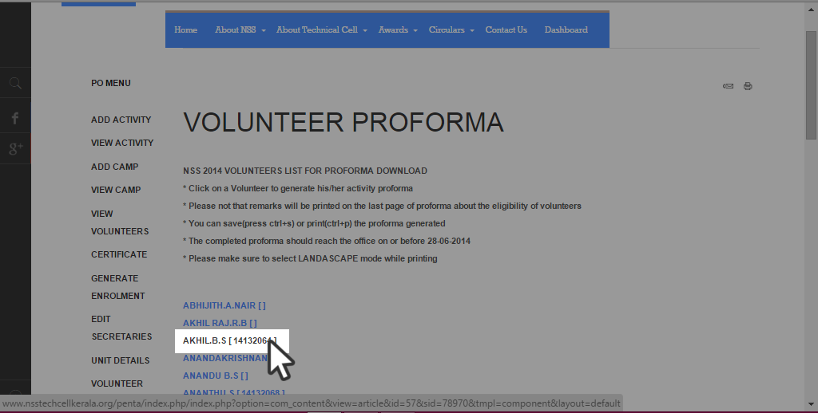
- Please note that remarks will be printed on the last page of proforma about the eligibility of volunteers. The completed proforma should reach the NSS office before the last date mentioned. Please make sure to select LANDASCAPE mode while printing.

- Here is the Activity chart of the volunteer.
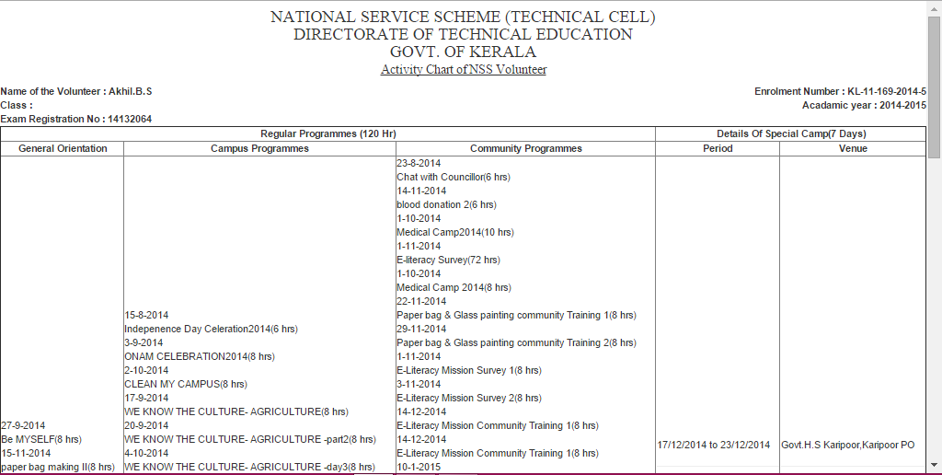
- Complete the proforma by signing the volunteer, programme officer, principal and send it to technical cell office.
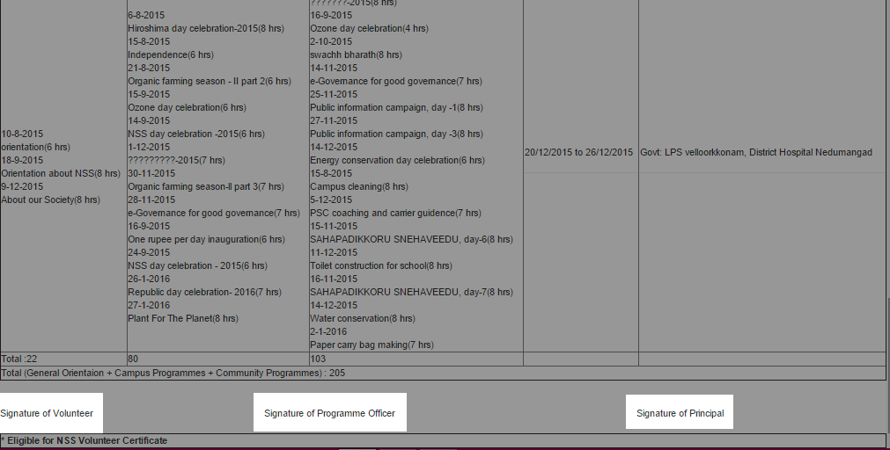

LOGOUT
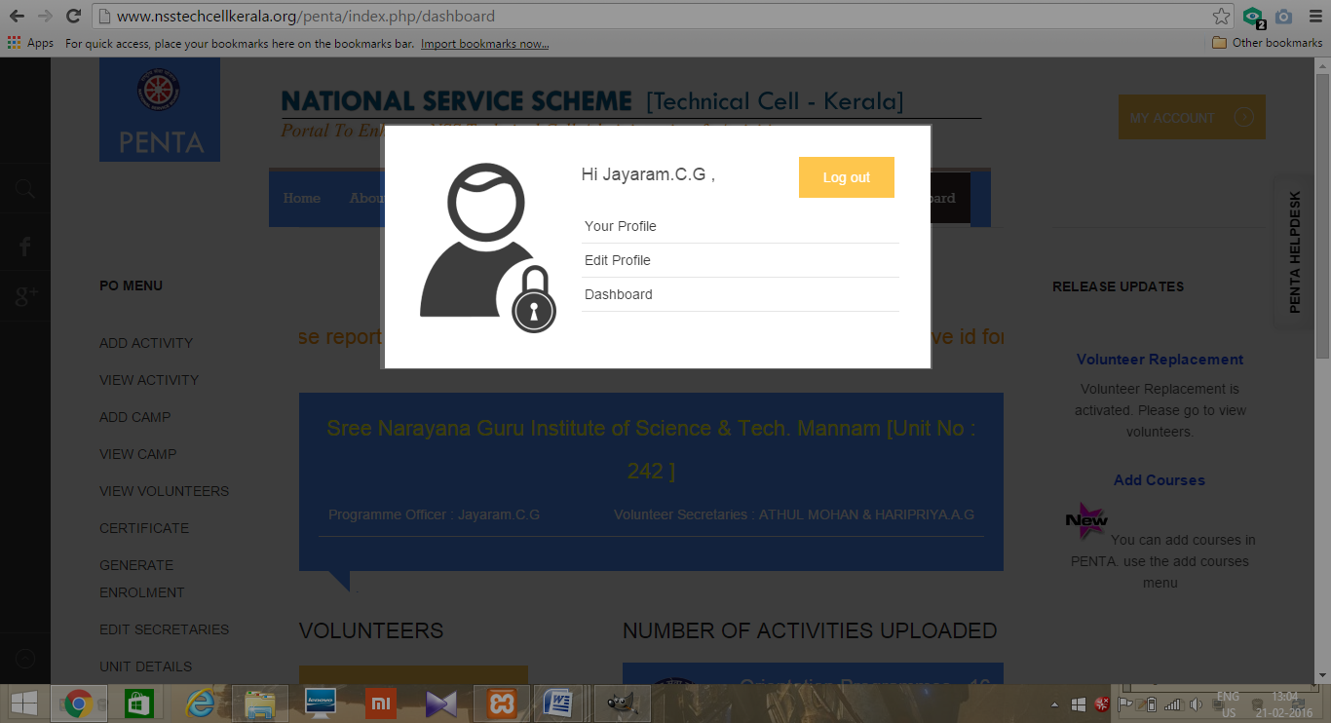
- Click MY ACCOUNT on the top right corner.
- Click logout.
