VIEW CAMP

PROGRESS FLOW OF VIEW CAMP

REVISED BY
Date | Description | Author | Version
21/02/2016 | USER MANUAL FOR VIEW CAMP | Ananthu.s | 1.0

LOGIN FOR PO

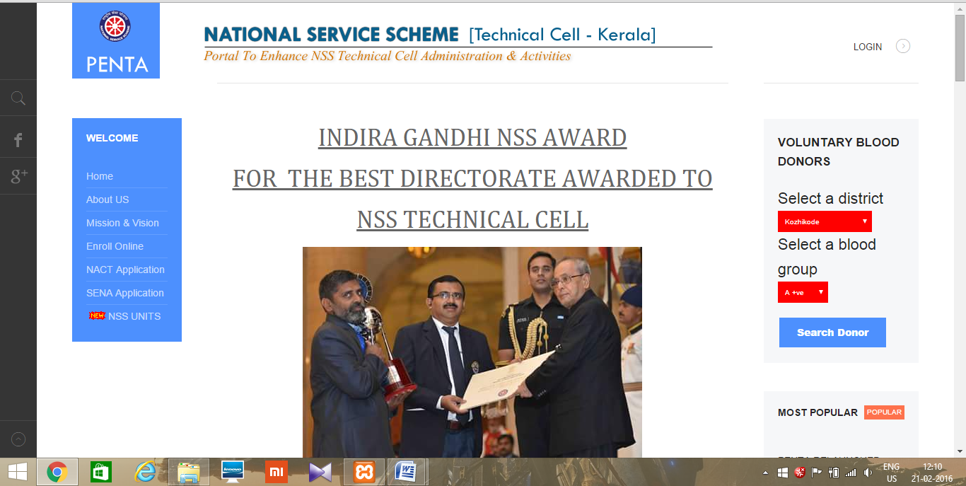
- Open Mozilla firefox/Google Chrome and type the address http://www.nsstechcellkerala.org/penta/ and press enter the following page will load.
- Click LOGIN
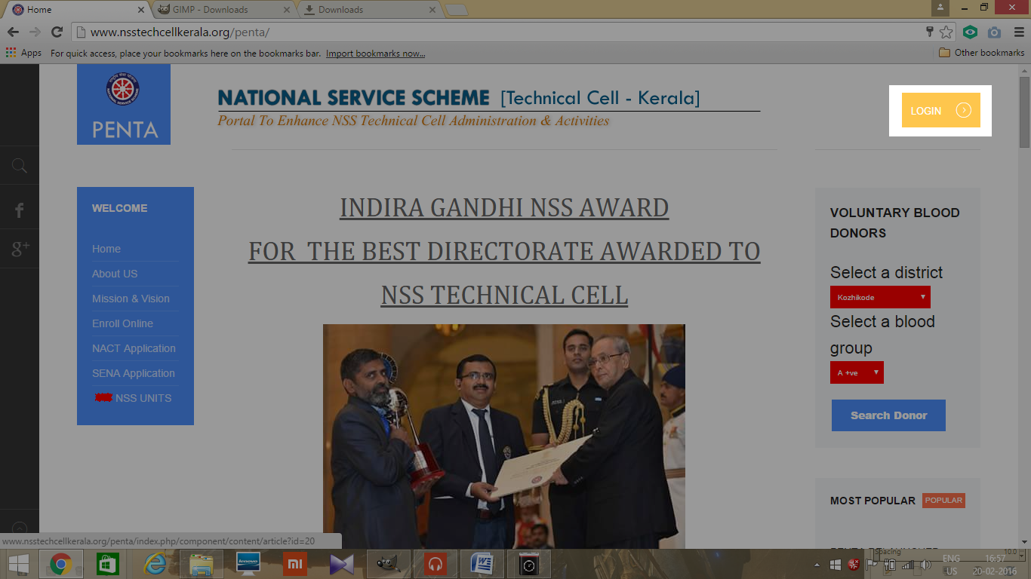
- Then enter USERNAME and PASSWORD of Programme officer
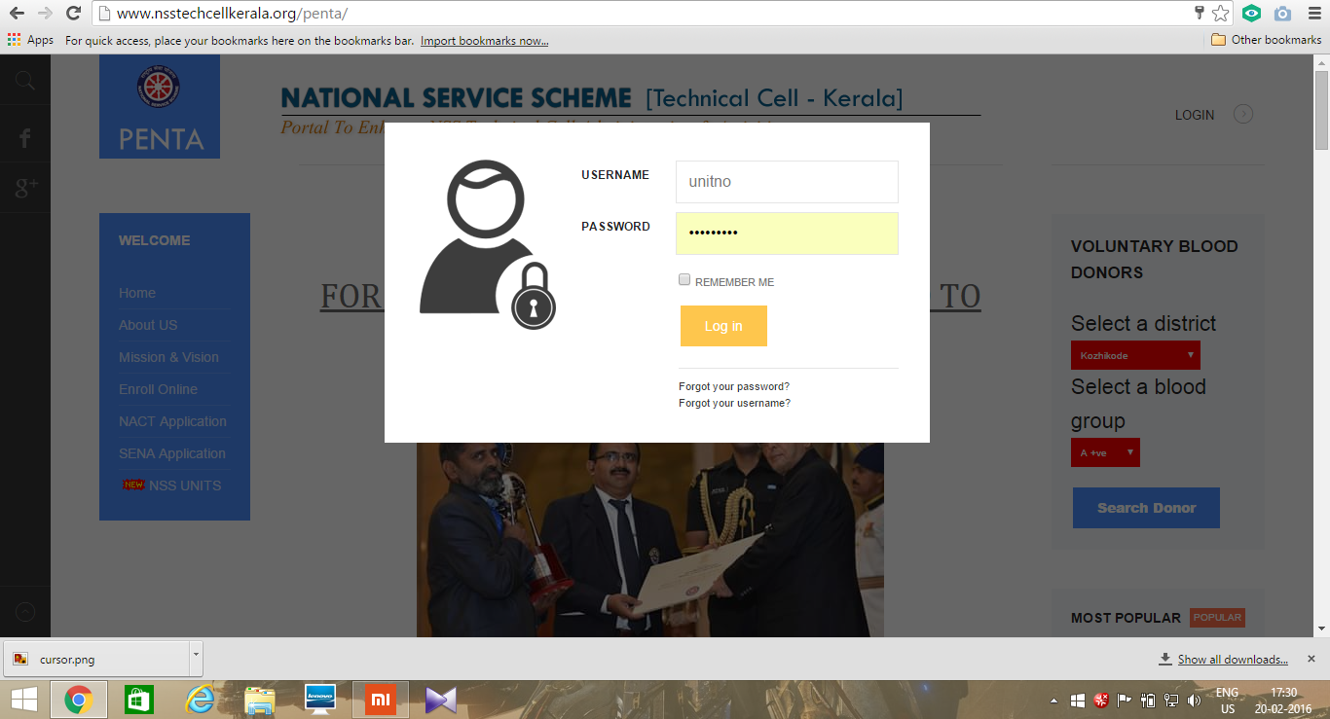
- Then the following dashboard will open
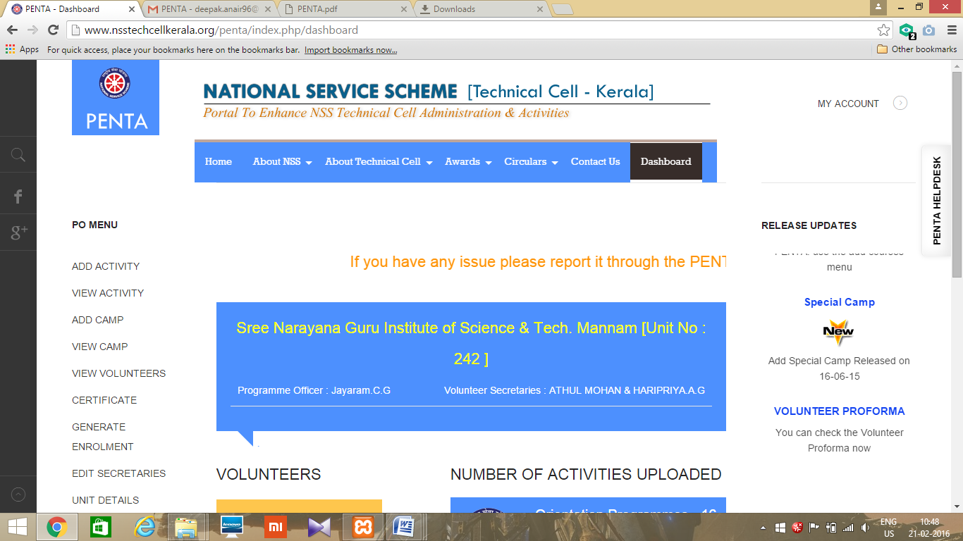

VIEW CAMP

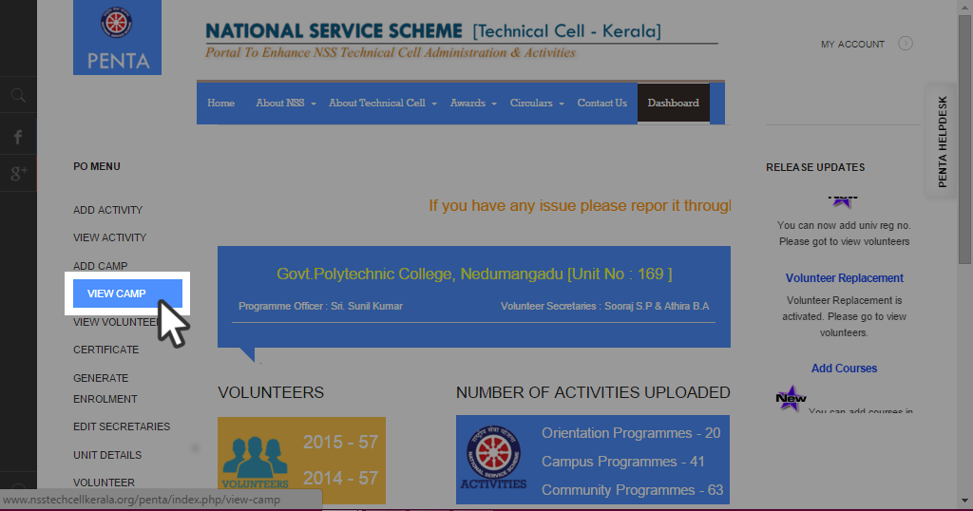
- After login, from the dashboard select the link VIEW CAMP.
- Then appear a new window with the detailed list of uploaded Special camps.
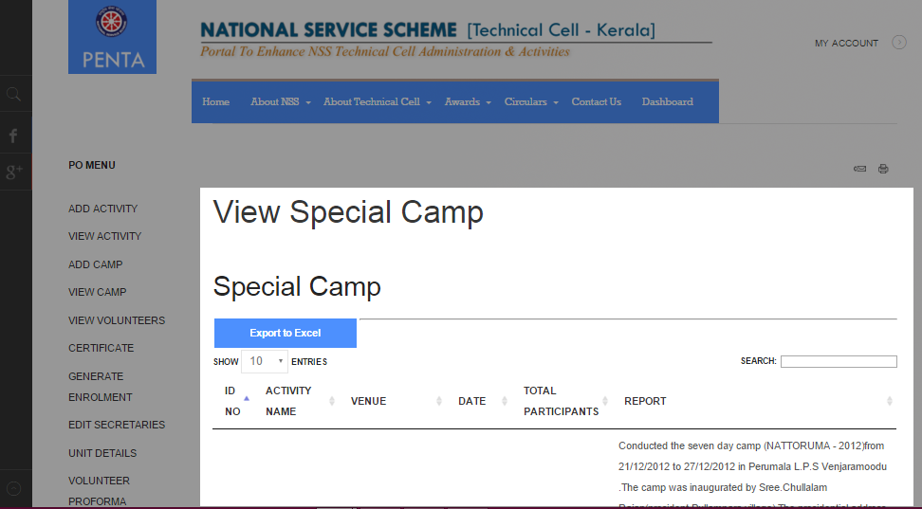

- From the appeared window we can see the unique ID of uploaded camp (Use this unique id when you putting a ticket in penta help desk), Camp name, Venue, Date of camp, number of participants and the detailed report of the camp you are uploaded. And also you can search for uploaded camp and export the list into an Excel file with desired number of camp entries (10, 25, 50, and 100).

LOGOUT
- Click MY ACCOUNT on the top right corner
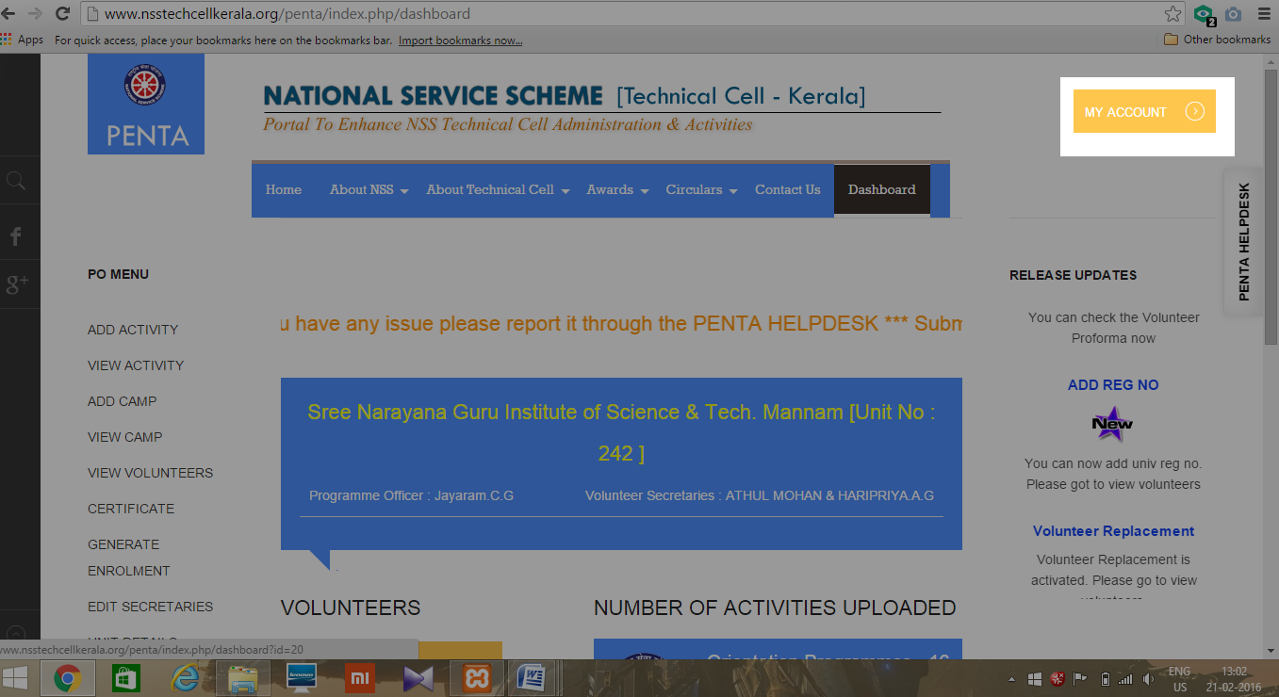
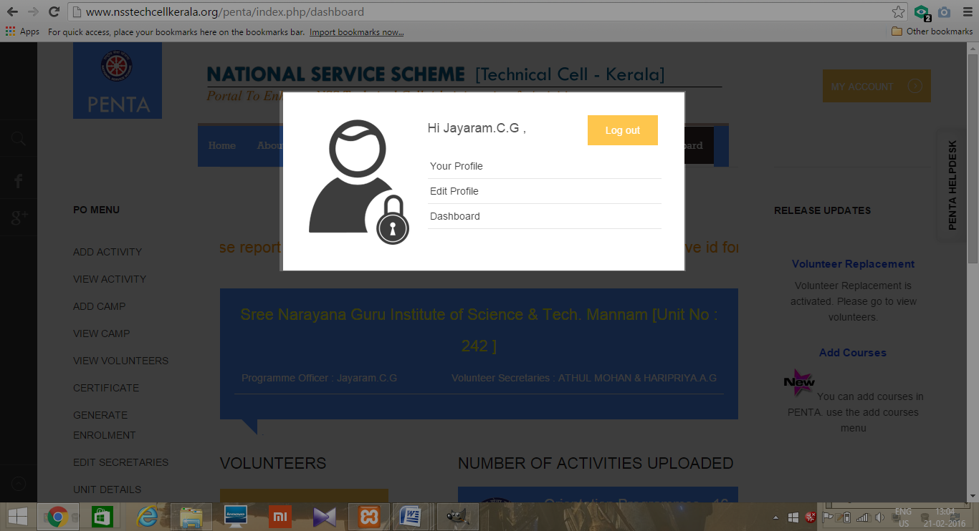
- Click LOGOUT.

