ADD CAMP

PROGRESS FLOW OF ADD CAMP

REVISED HISTORY
Date | Description | Author | version
21/02/2016 | USER MANUAL FOR ADD CAMP | Juhi Fatimah | 1.0

LOGIN FOR PO

1.Open Mozilla firefox/Google Chrome and type the address http://www.nsstechcellkerala.org/penta/ and press enter.The following page will be loaded.
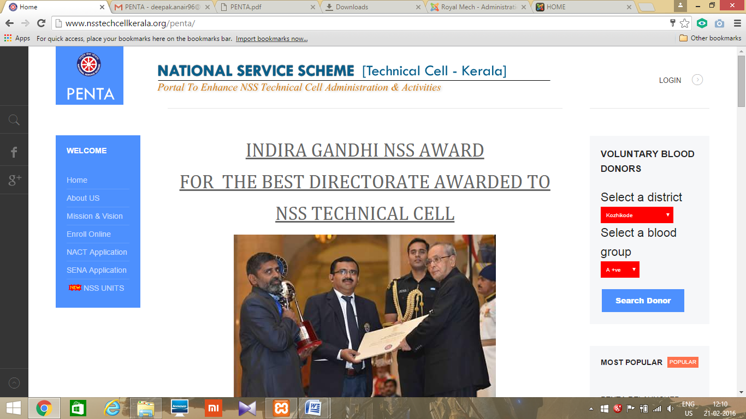
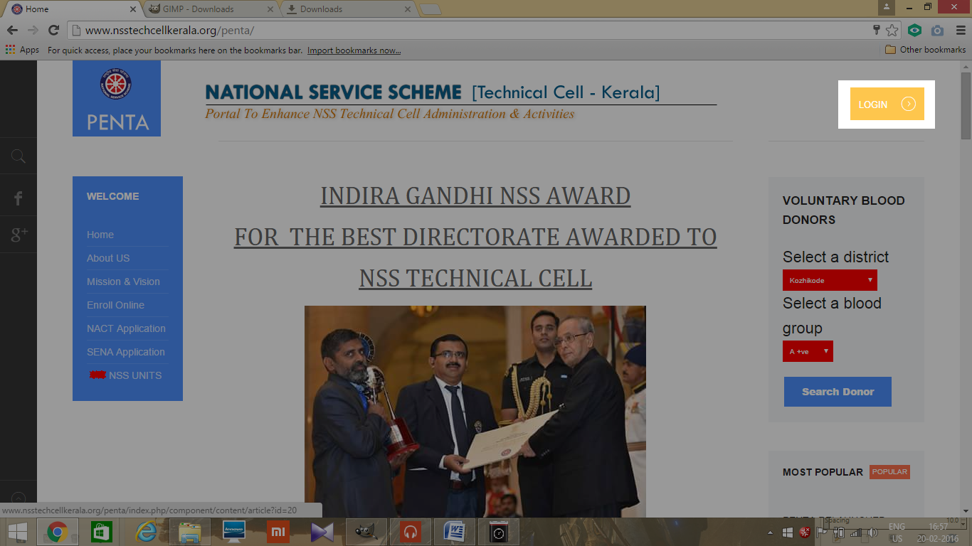
2. Click LOGIN

3. Then enter USERNAME and PASSWORD of P.O
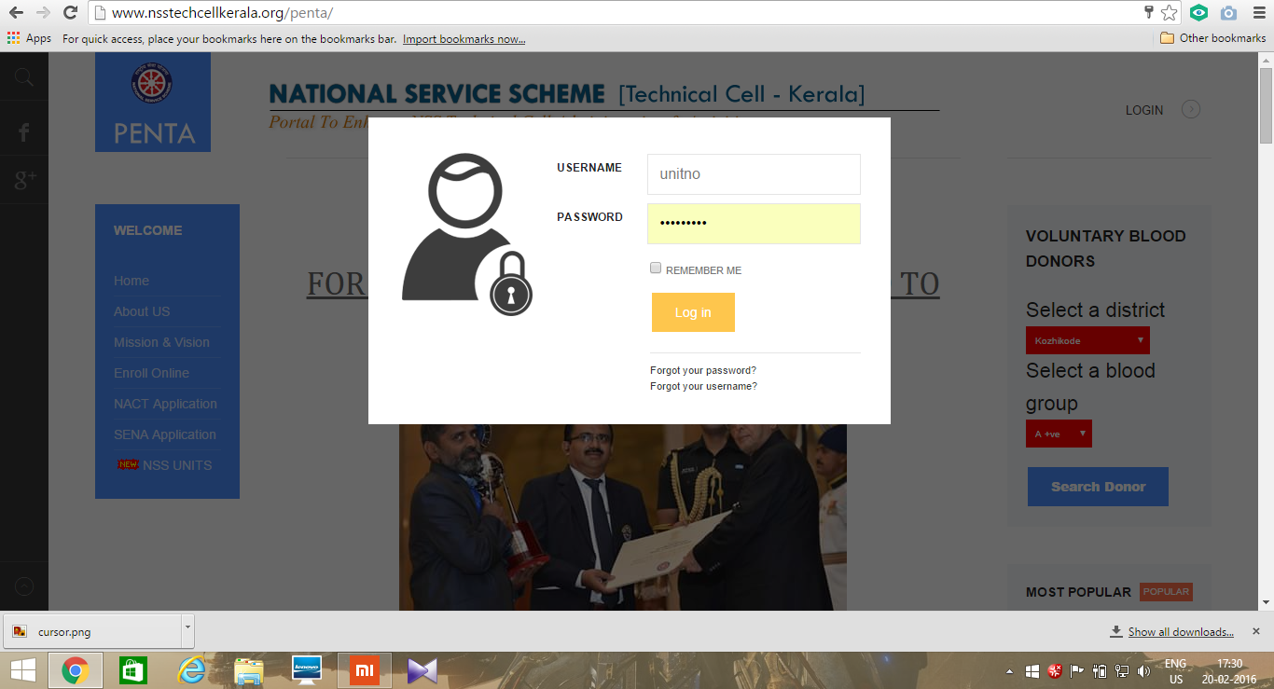

4. Then the following dashboard will be opened.
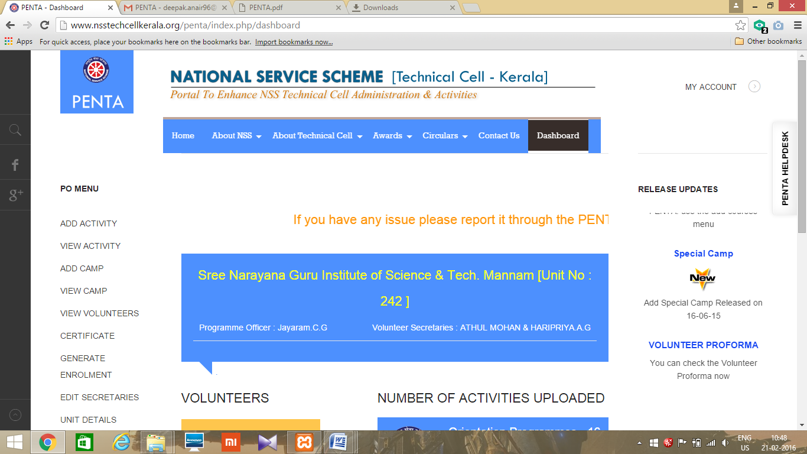

ADD CAMP

5. Select the link ADD CAMP from the dashboard after logging in. Note that the ADD CAMP link is used only for updating seven day special camp.
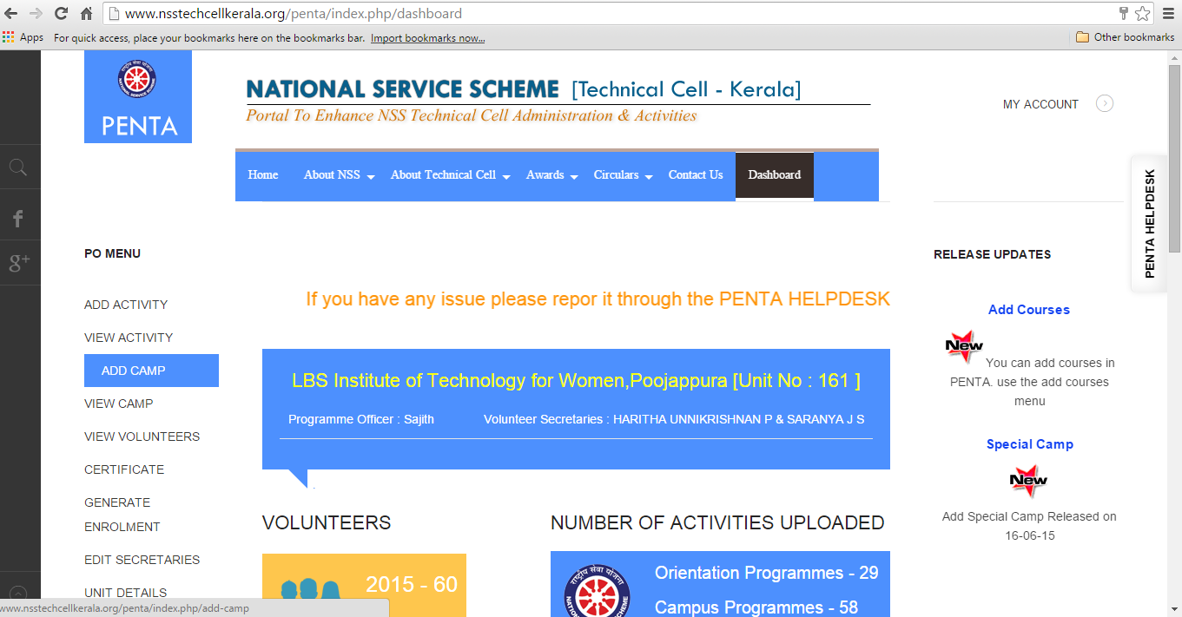

6. Enter the activity details i.e. Camp title, venue, starting & ending dates with a brief description not more than 1000 characters. The * marked fields are mandatory.
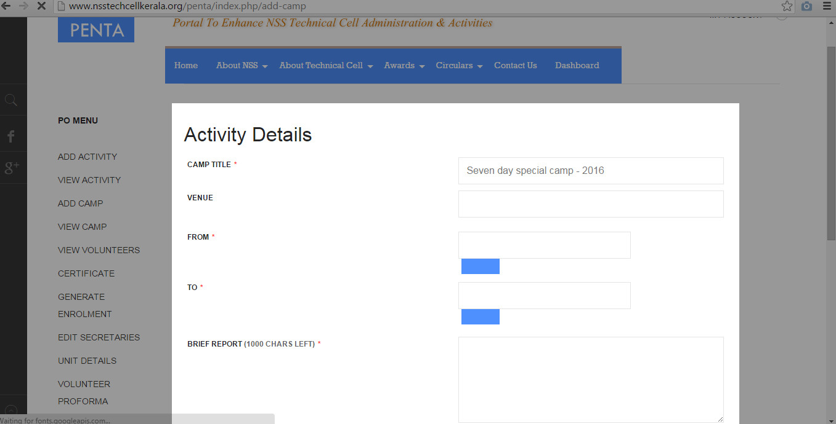
7. Then choose image files and upload the photos and news report of the camp. The size of photo should not exceed 200 kb. Use adds more option to upload more photos.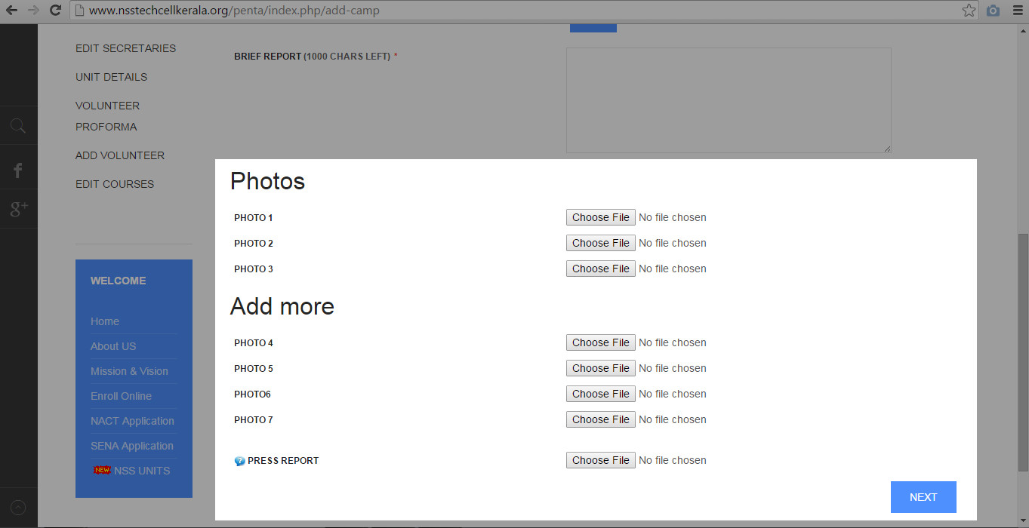
8. Then click NEXT. Enter achievements of camp in given columns.(Achievements of the camp, construction of road, construction of play ground,Immunisation,Educational session, Health camps, Environmental activities).Enter the approximate value in Rs. And remarks against each column. And click next.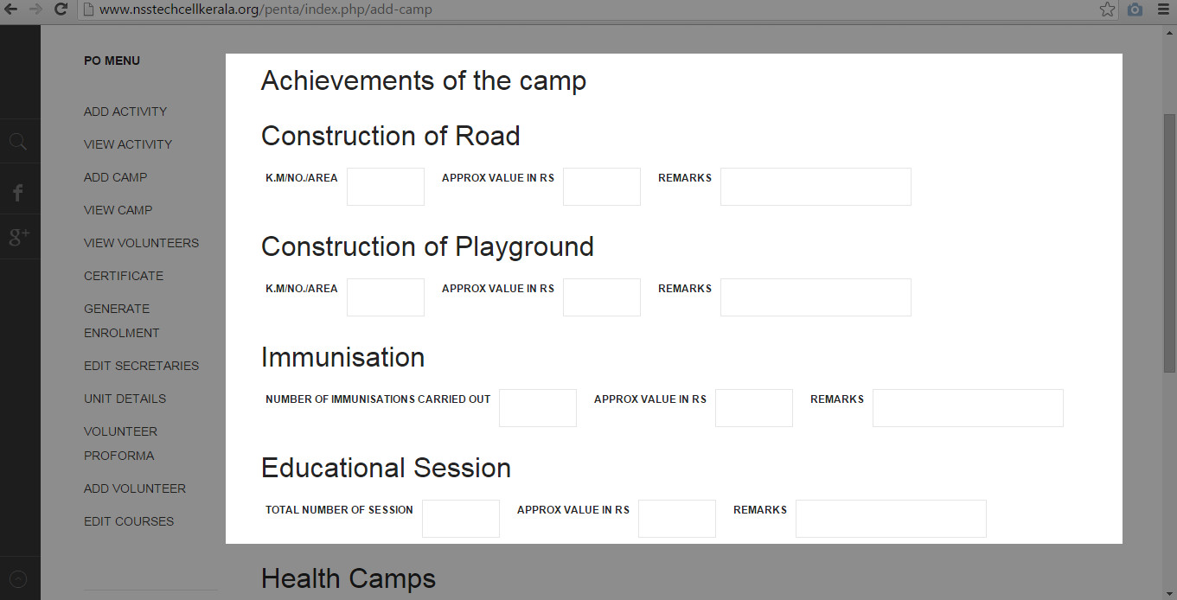 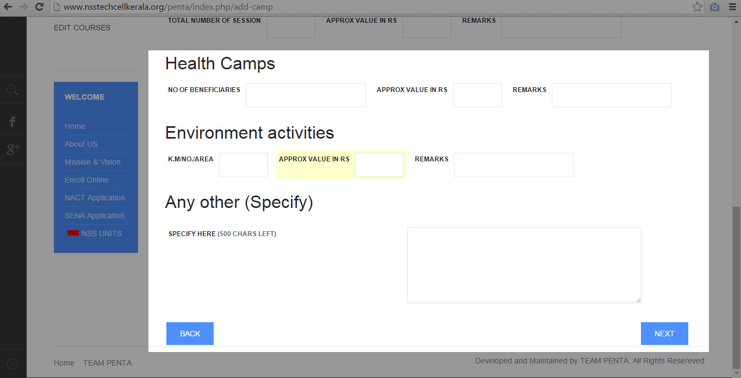
9. Now select the names of participated volunteers from given list. The no.of volunteers participated will be shown automatically in the corresponding column. Then click on SUBMIT button.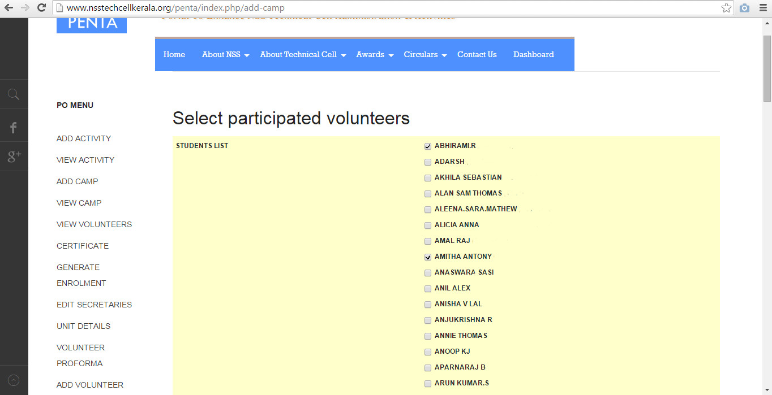
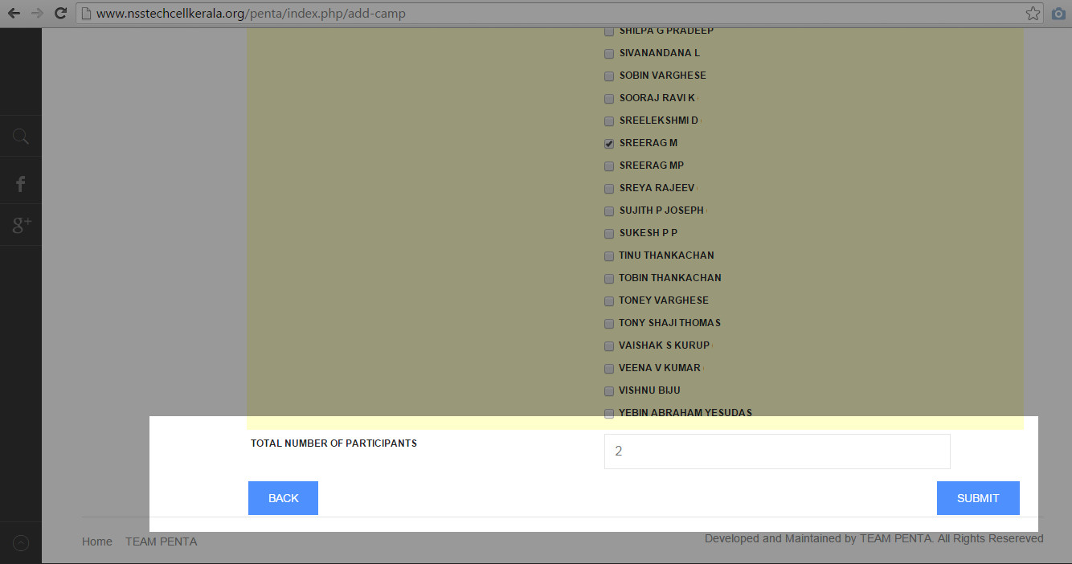
10. After submission, a pop up will appear with message “successfully updated New Camp”.
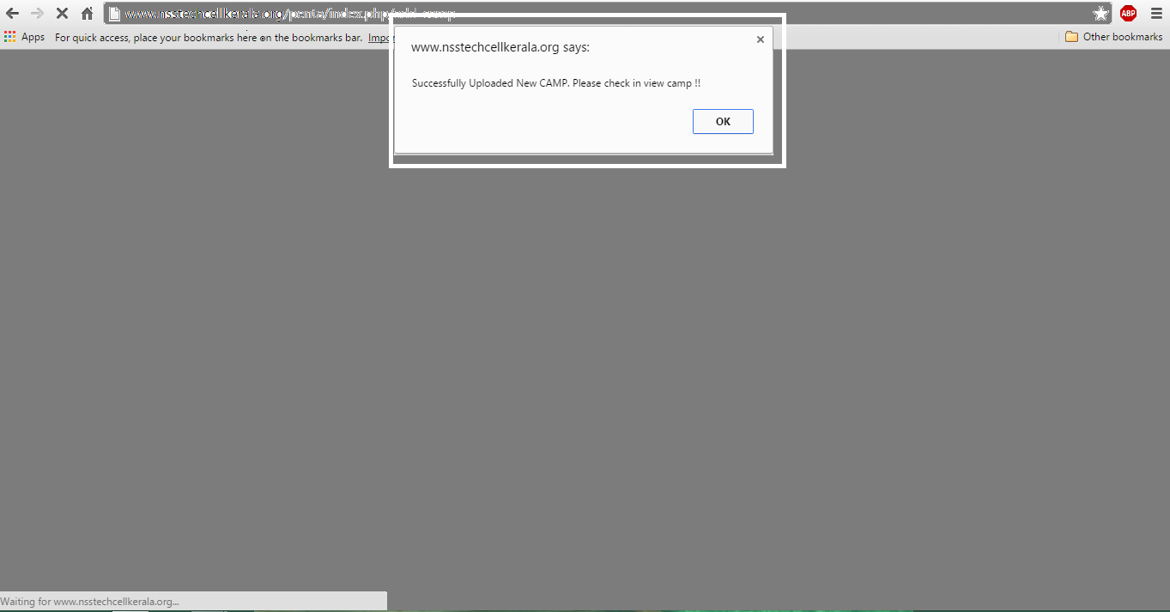

LOGOUT
11. Click MY ACCOUNT on the top right corner.
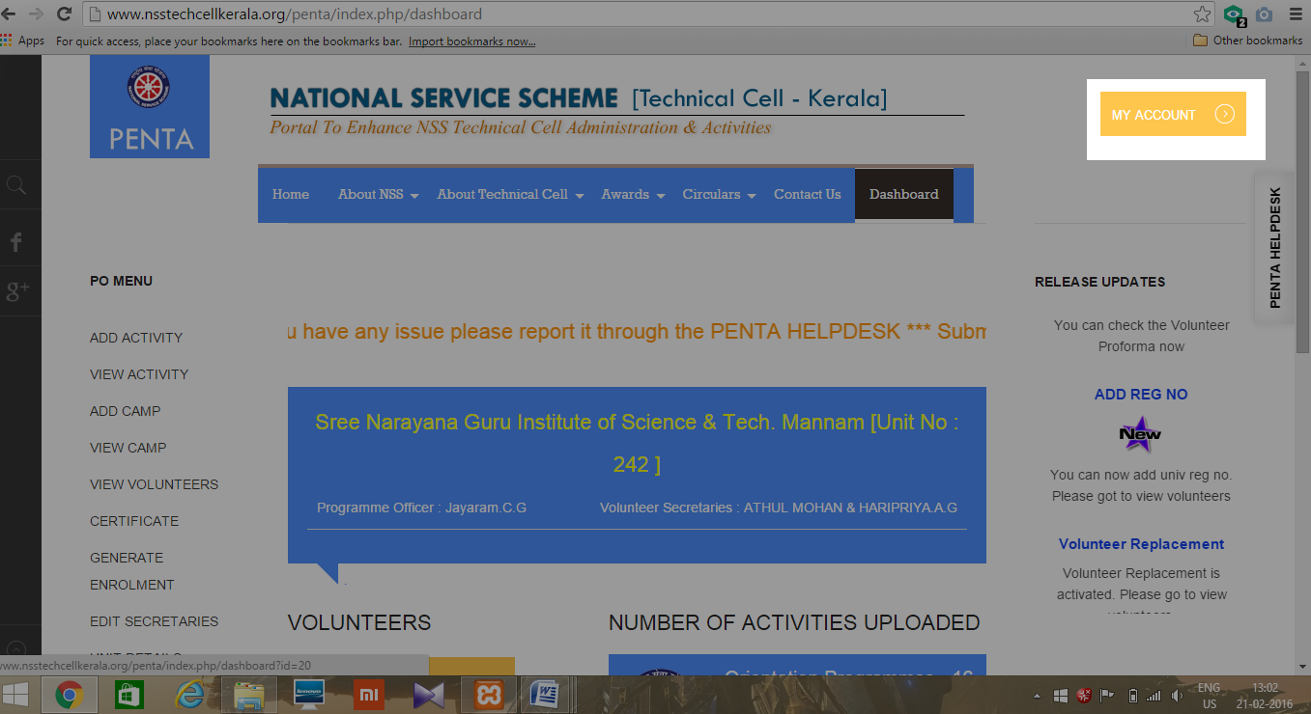
12. Click LOG OUT
