CERTIFICATE GENERATION

GENRAL INSTRUCTIONS

- PENTA ID CAN ALSO AVAILBAE IN VIEW VOLUNTEER.
- THE PERFOMA SHOULD BE SENT TO NSS TECH CELL OFFICE.
- THE CERTIFICATE ONLY AVAILABLE WHEN PERFOMA HAS BEEN APROVED FROM NSS TECH CELL OFFICE.

REVISION HISTORY
Date | Description | Author | VERSION
21/02/16 | USER MANUAL FOR CERTIFICATE GENERATION | HASHIR AHAMED.P | 1.0

PROGRESS FLOW OF CERTIFICATE GENARATION

LOGIN FOR PO
- Open Mozilla firefox/Google Chrome and type the address http://www.nsstechcellkerala.org/penta/ and press enter the following page will load.

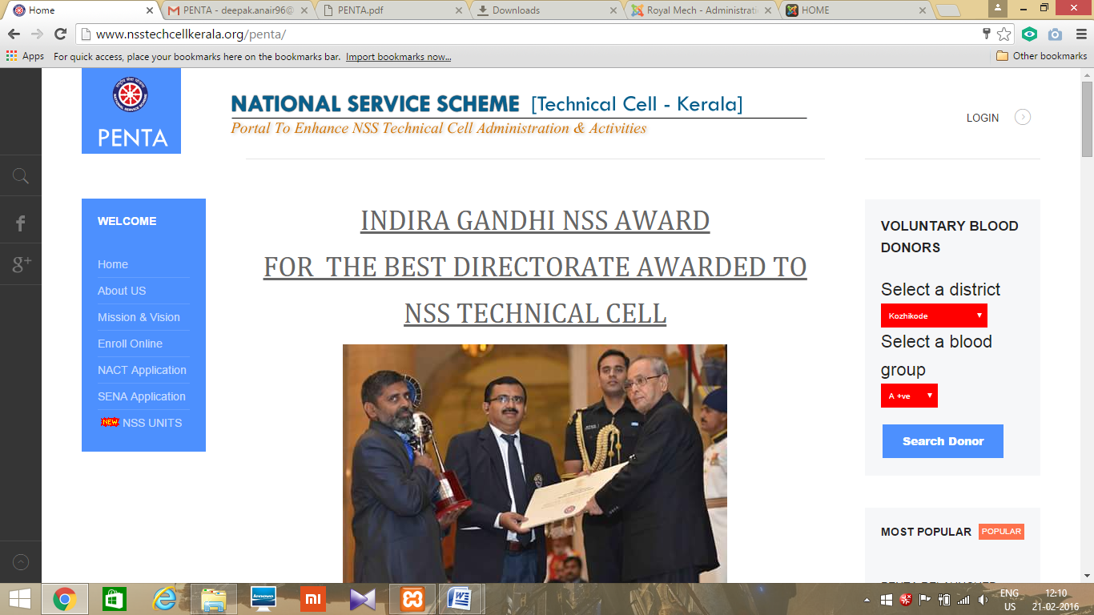

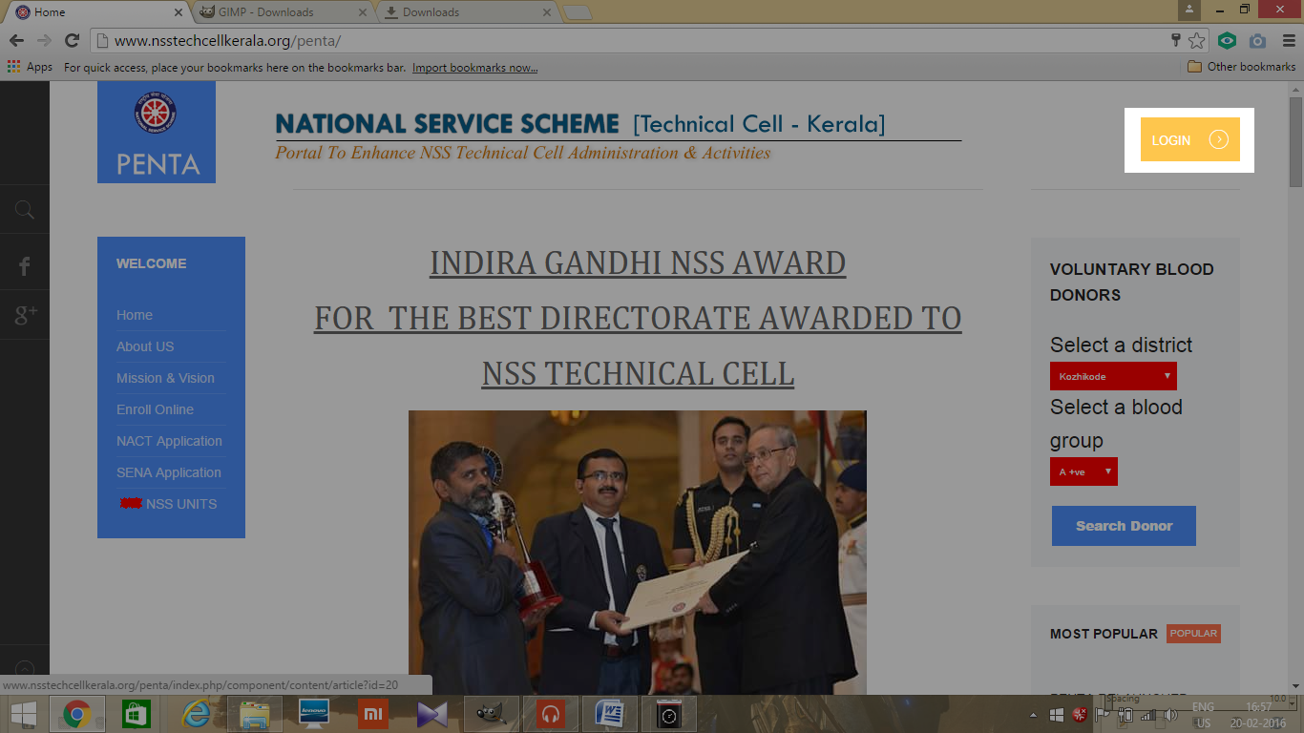
- Click LOGIN

- Then enter USERNAME and PASSWORD of PO and click login
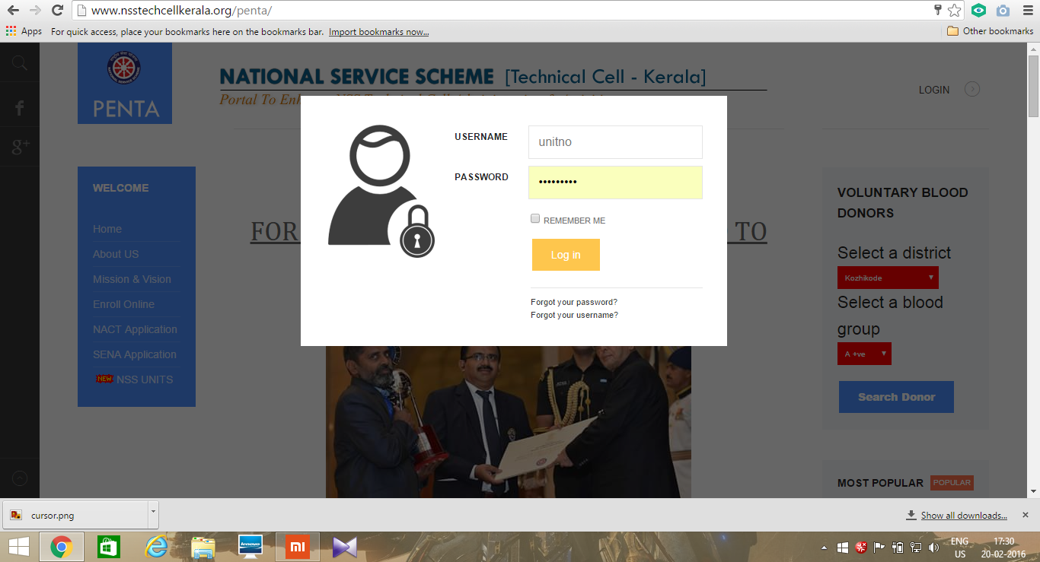

- Then the following dashboard will open
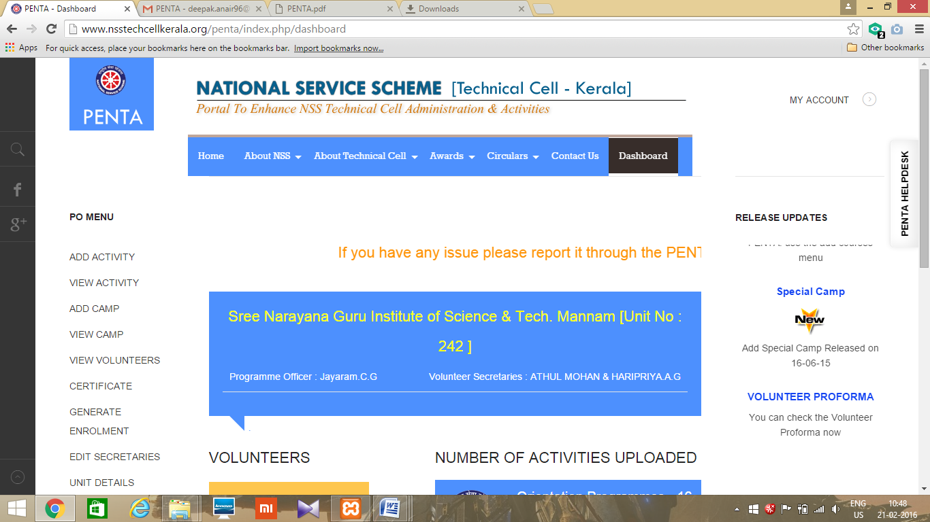

GENERATE CERTIFICATE

- CLICK ON CERTIFICATE ON LEFT CORNER
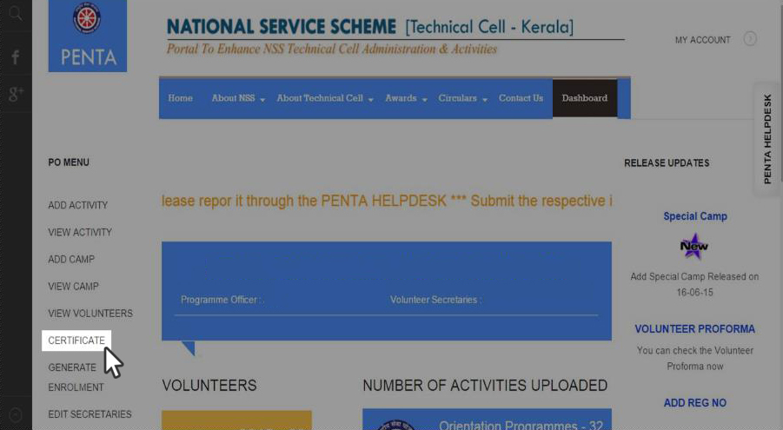

- ENTER THE PENTA ID OF THE VOLUNTEER WHO YOU WISH TO GENERATE THE CERTIFICATE AND CLIK ON SUBMIT LINK
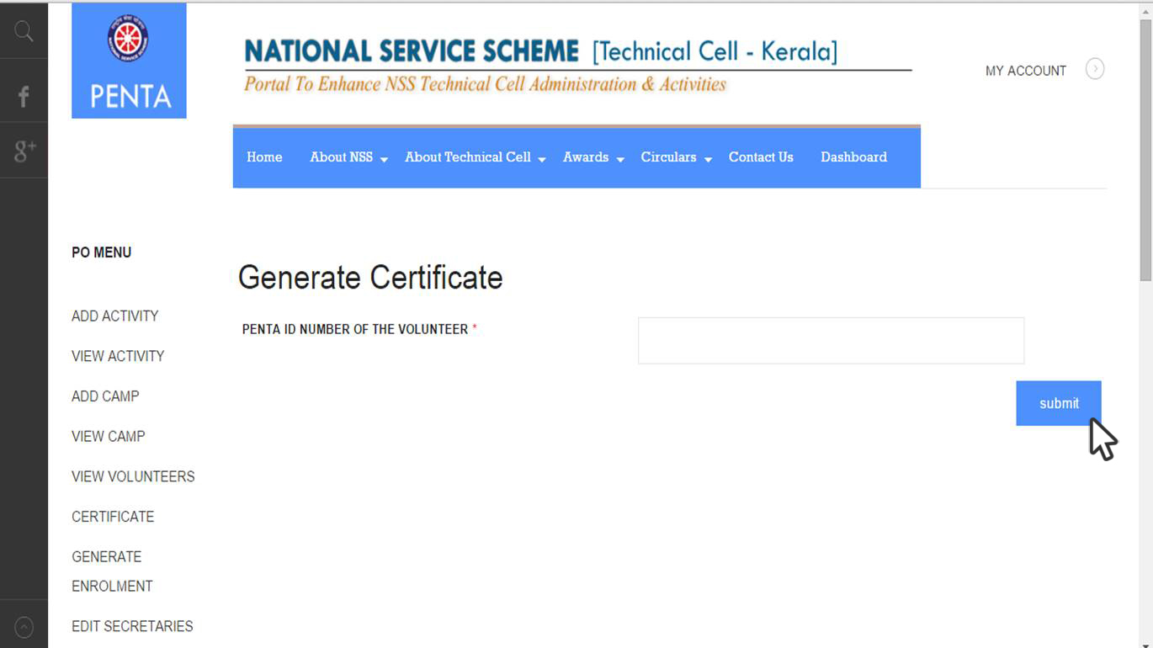
- CERTIFICATE WILL BE GENERATED
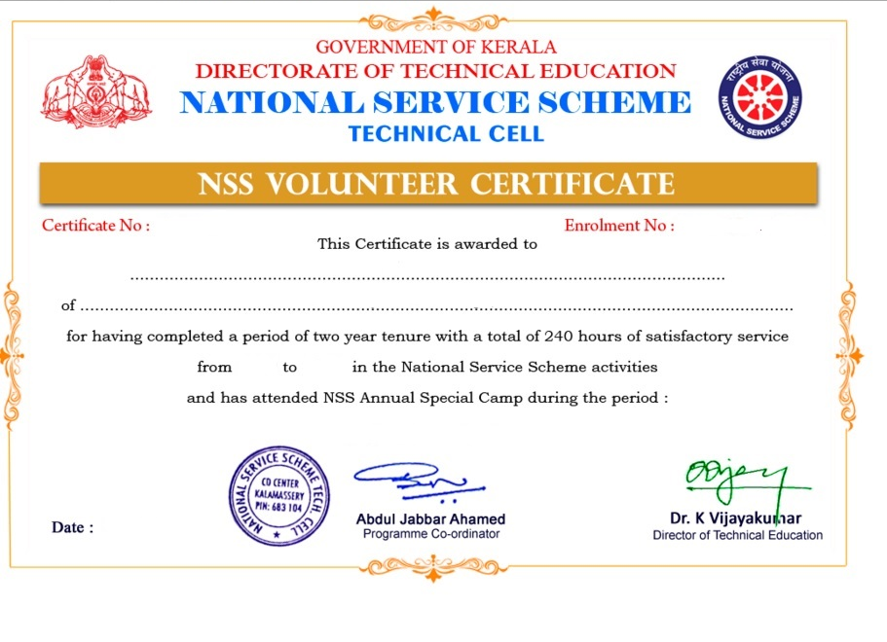

LOGOUT

- Click MY ACCOUNT on the top right corner.
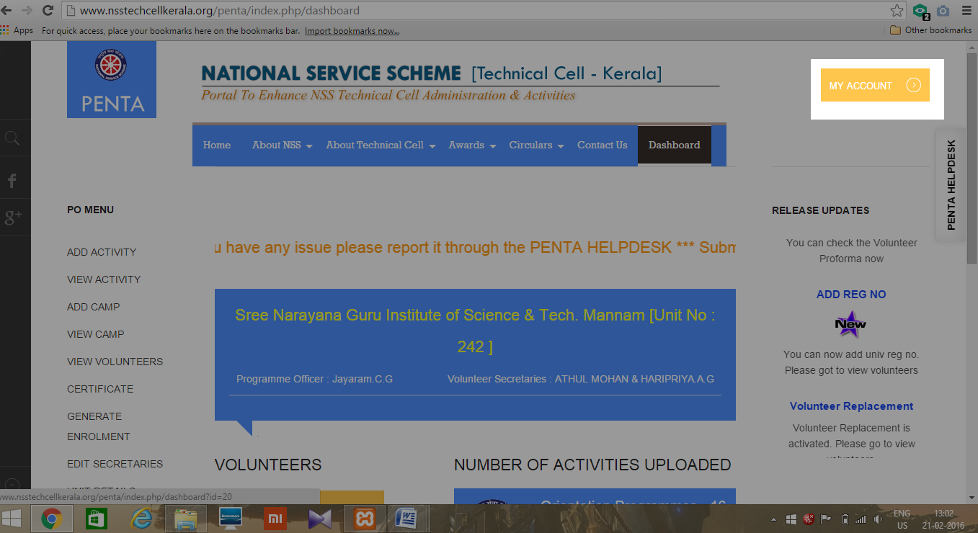

- Click LOGOUT
