HELP DESK/ SUPPORT

RIVISION HISTORY
21/02/2016 | USER MANUAL FOR HELP DESK/SUPPORT | ARUN JISHNU | 1.0

PROGRESS FLOW OF PO APPROVAL

COMPLAINT REGISTRATION/SUPPORT

- For support go to the url support.nsstechcellkerala.org
- Then you will be redirected to the support page of NSS TECH CELL
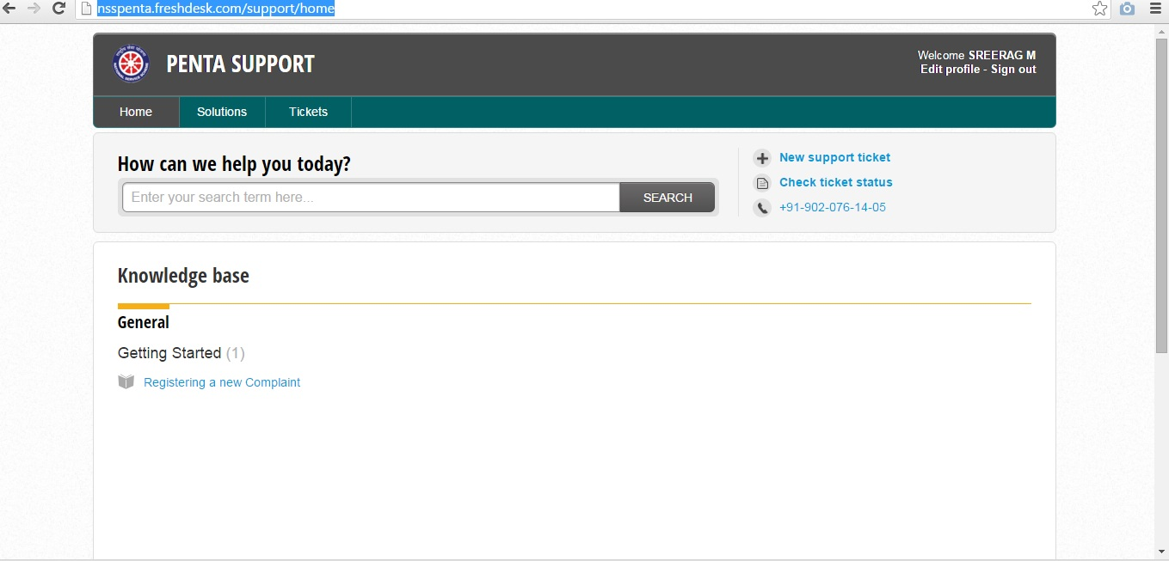

- Click the New support ticket

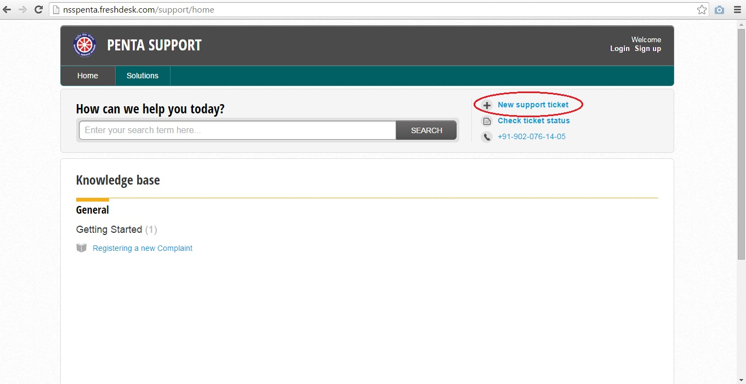
- Enter the details of your complaint carefully in the required fields.
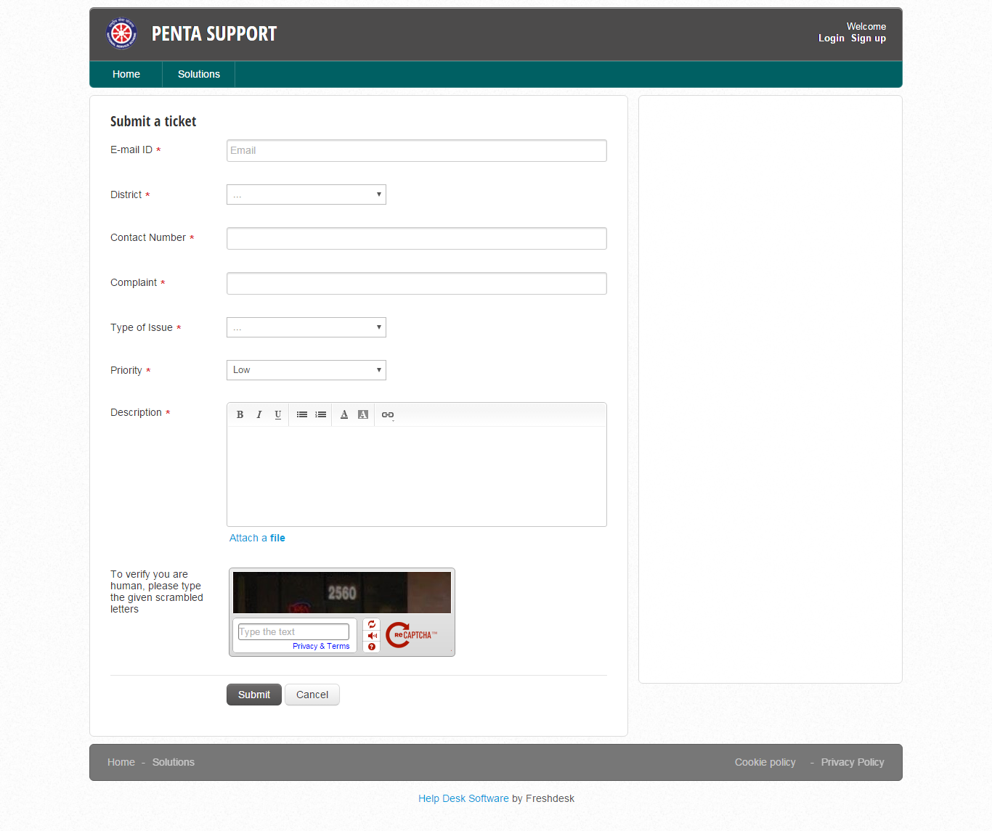
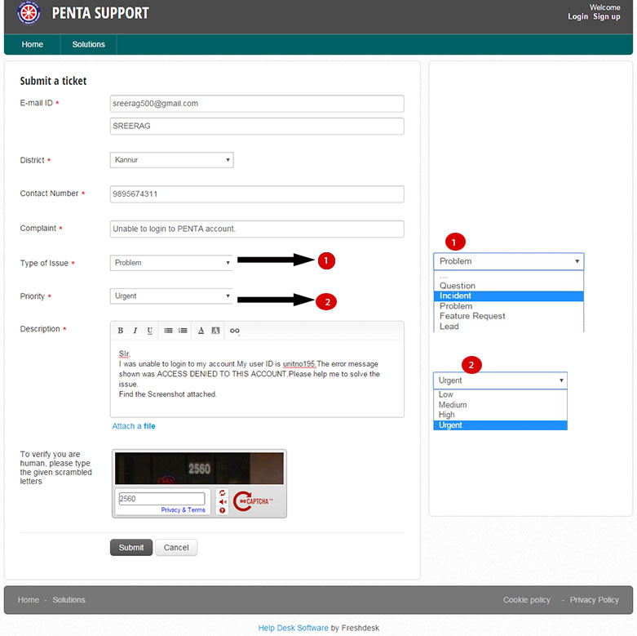

- Attach the screenshot of your problem (Recommended)
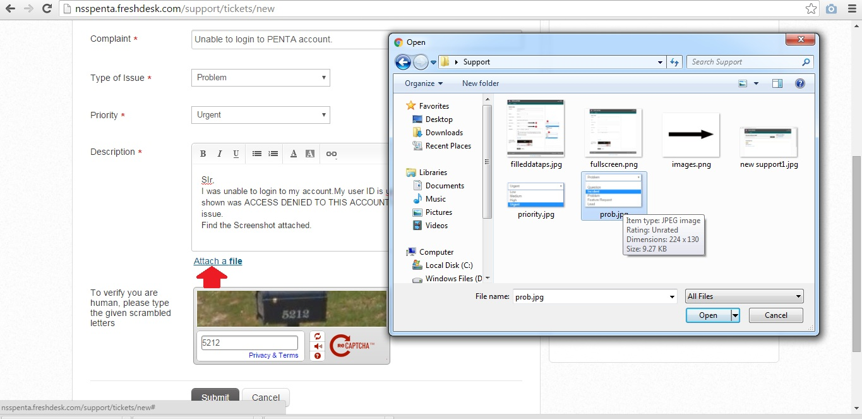
- Then press submit button
- You will receive an email from PENTA support team if the complaint is successfully registered.
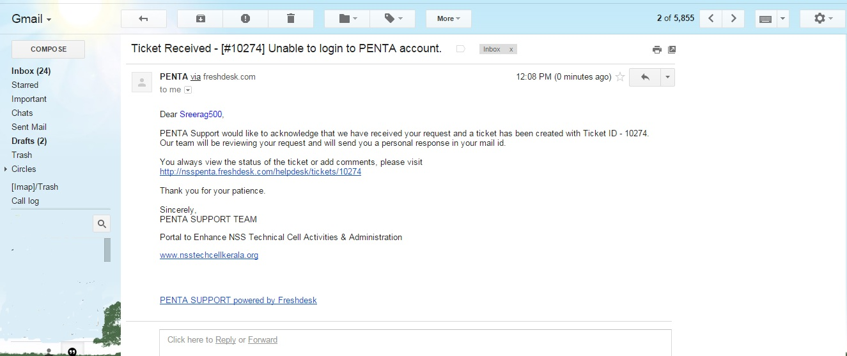

- You can view the status of the complaint from the link that is given in the email.

Note: For Program officers who signed in to their account can complaint directly from the page

FOR PROGRAM OFFICERS

- You can find a PENTA HELP DESK icon on the right end of the webpage.

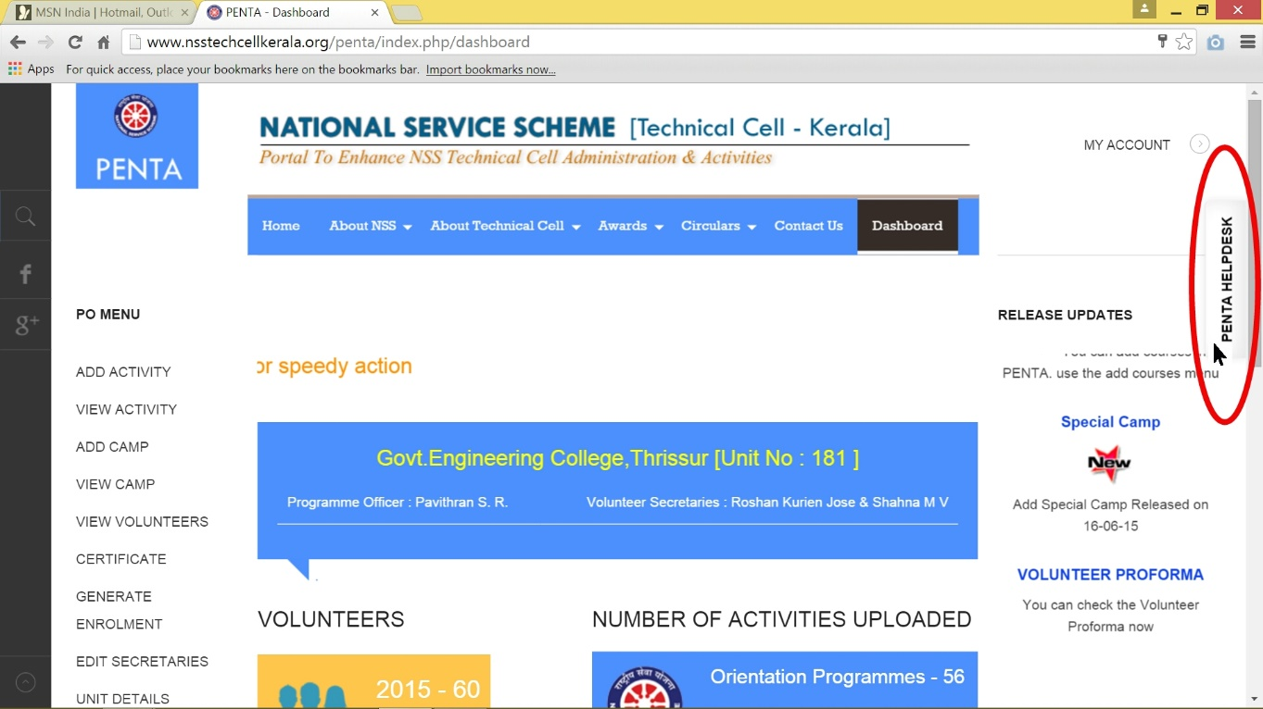

- Then a pop-up window will appear requesting the details of the complaint.
- Fill the required fields and click the submit button.
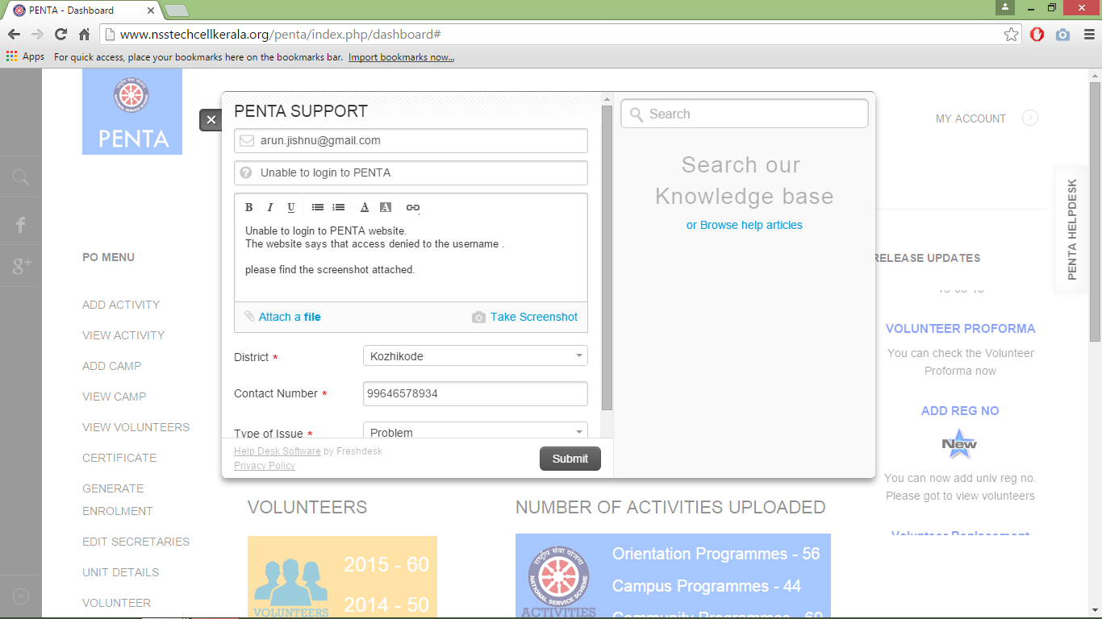

- You will be notified after successful submission.

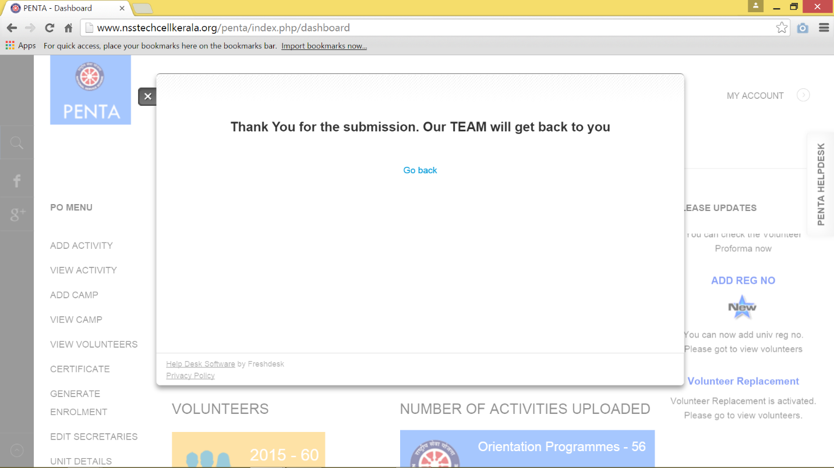
- You will receive an email from PENTA support team if the complaint is successfully registered.

- You can view the status of the complaint from the link that is given in the email.

