PO APPROVAL

REVISION HISTORY
Date | Description | Author | VERSION
21/02/16 | USER MANUAL FOR PO APPROVAL | DEEPAK A NAIR | 1.0

PROGRESS FLOW OF PO APPROVAL

LOGIN FOR PO
- Open Mozilla firefox/Google Chrome and type the address http://www.nsstechcellkerala.org/penta/ and press enter the following page will load.

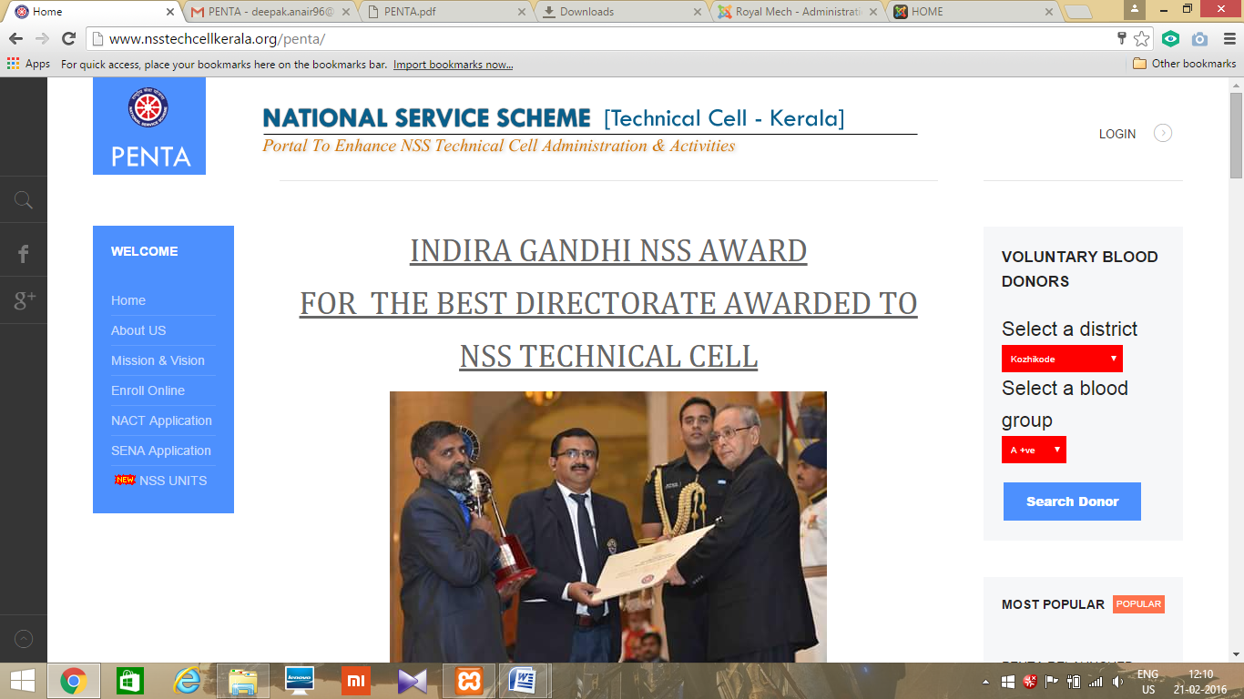

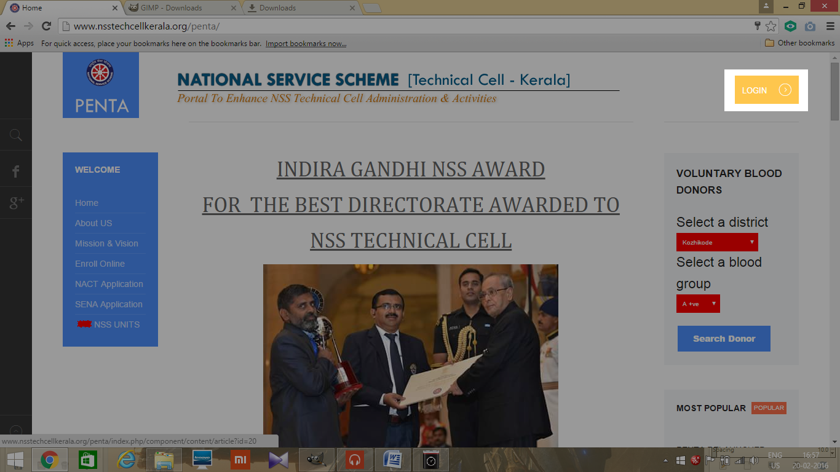
- Click LOGIN

- Then enter USERNAME and PASSWORD of PO and click login
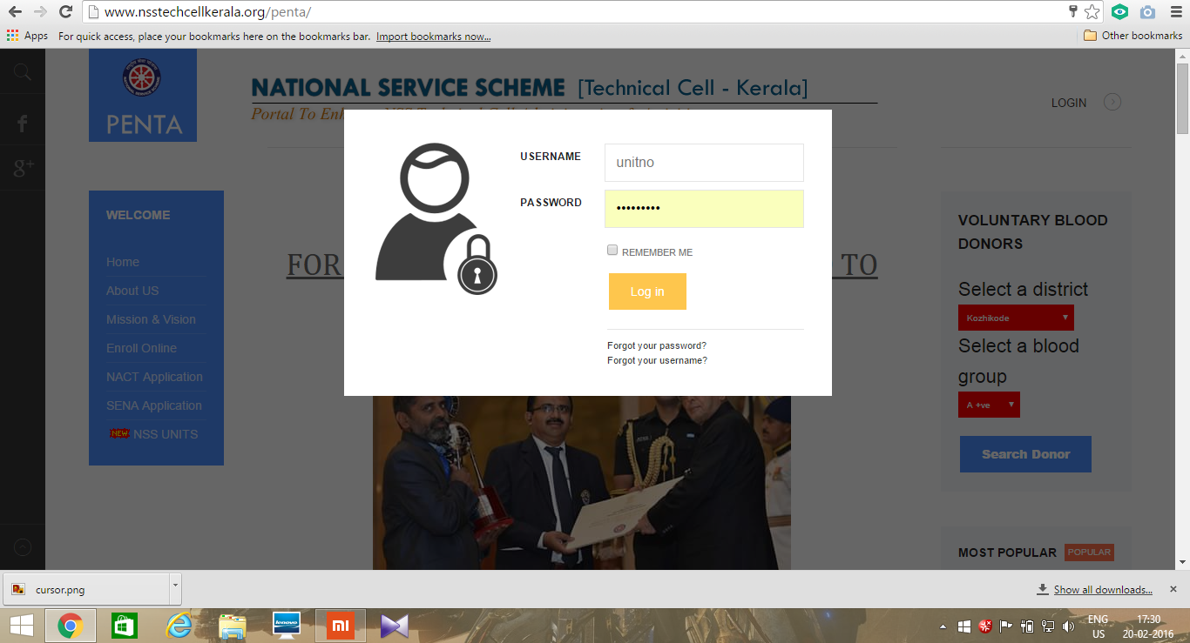

- Then the following dashboard will open
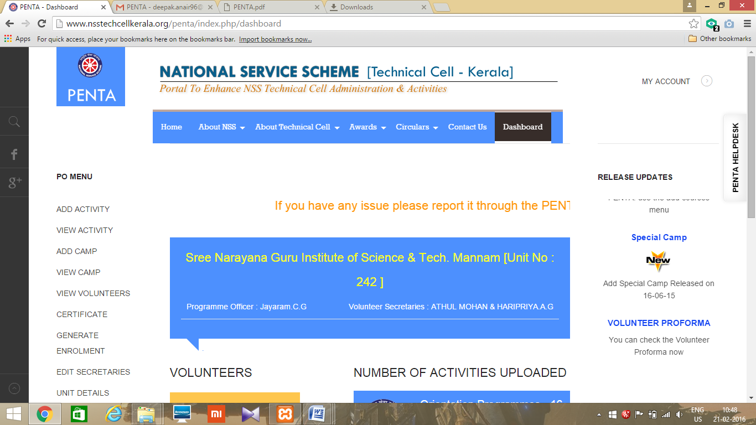

PO APPROVAL
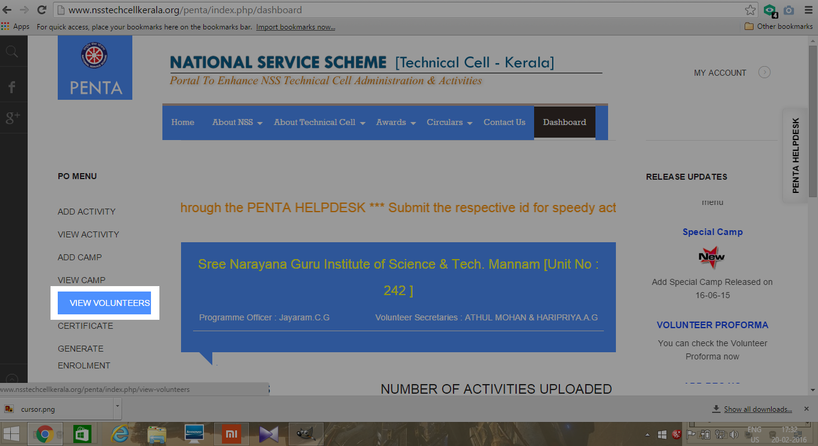
- Press VIEW VOLUNTEERS, after login

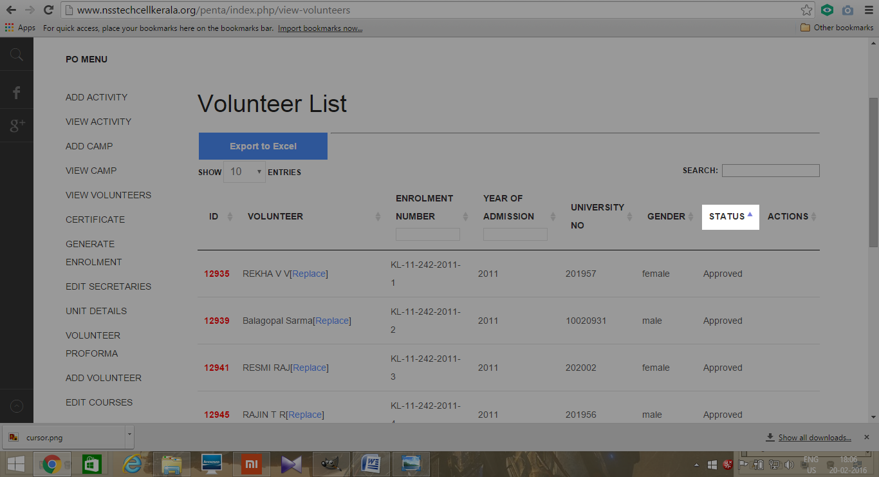
- Click on the arrow near status to see status of volunteer's

- Click approve to approve the volunteers
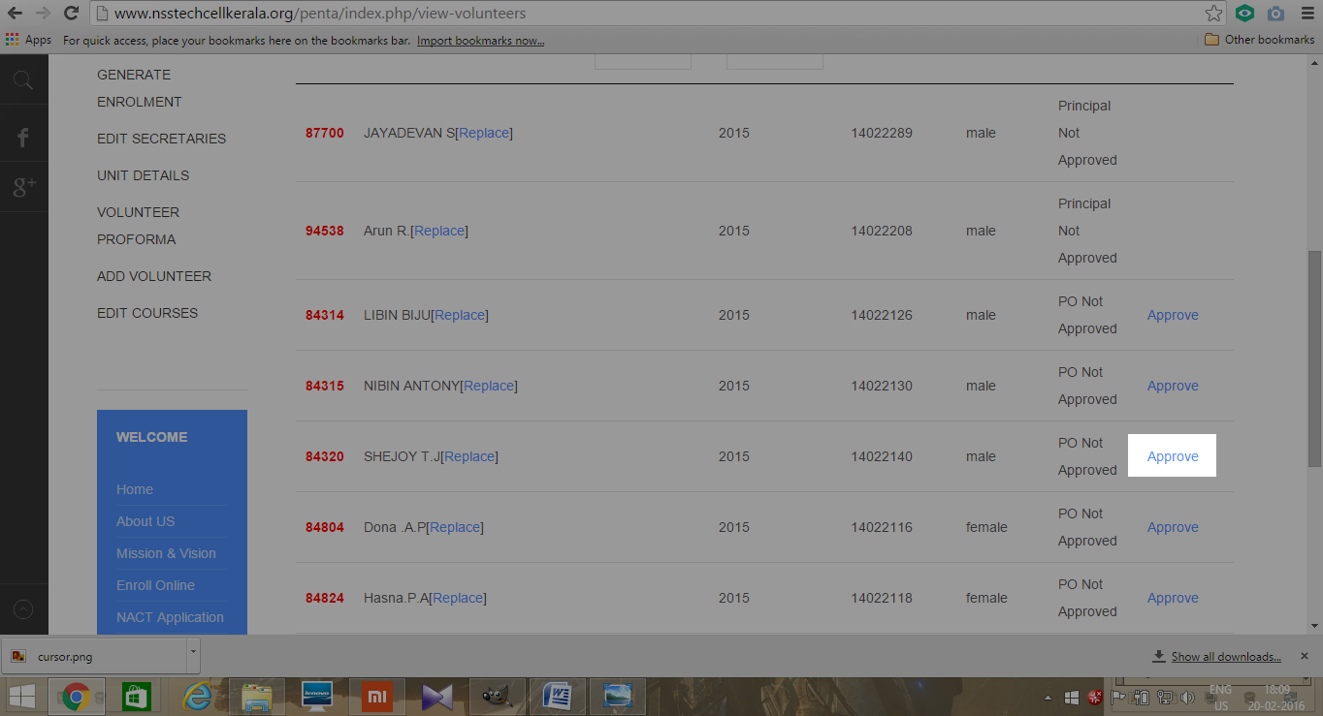
- Then Status will change to Principle Not Approved
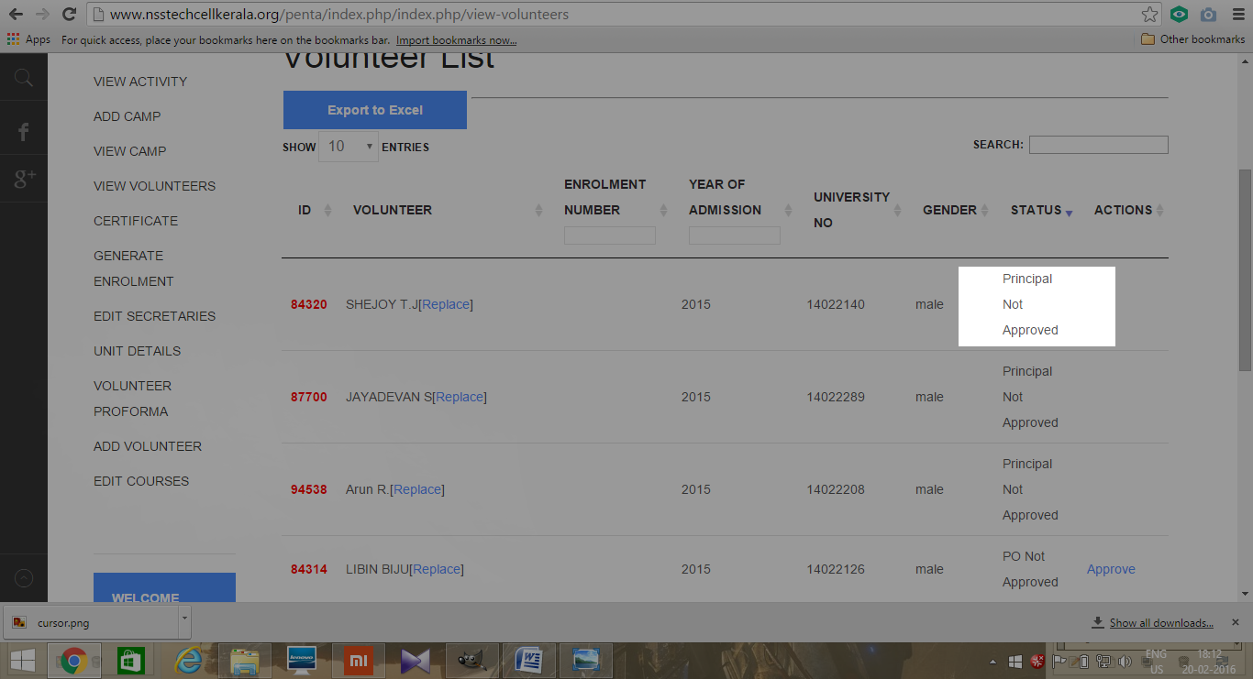

LOGOUT
- Click MY ACCOUNT on the top right corner.
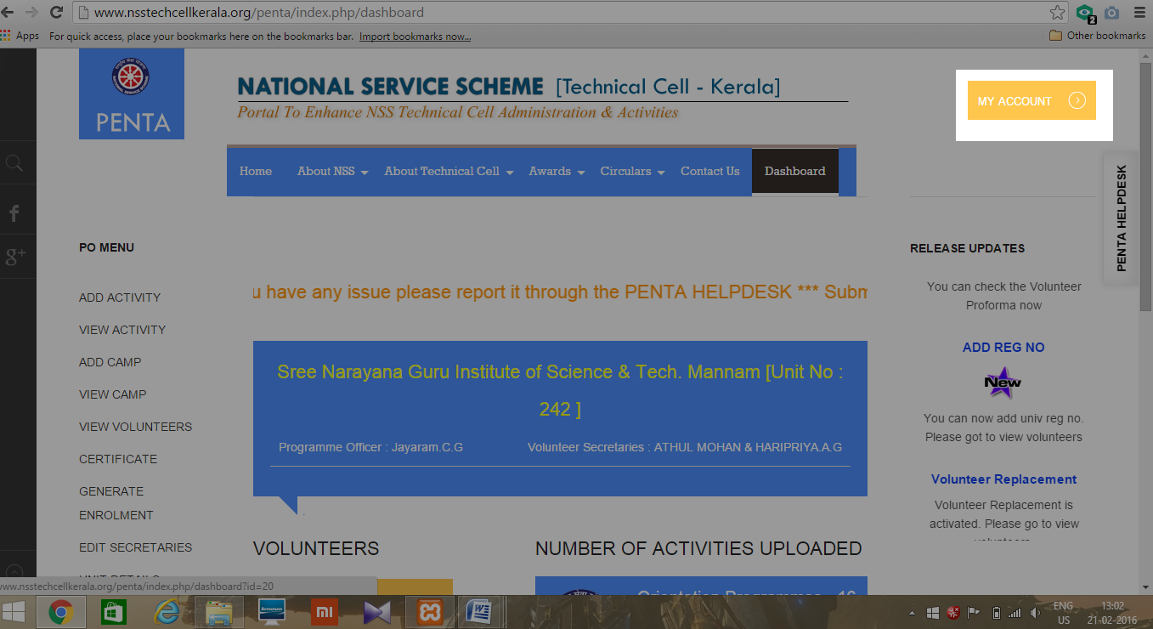
- Click LOGOUT
