PO LOGIN

REVISION HISTORY
Date | Description | Author | VERSION
21/02/16 | USER MANUAL OF LOGIN FOR PO | DEEPAK A NAIR | 1.0

PROGRESS FLOW OF CERTIFICATE GENARATION

LOGIN FOR PO
- Open Mozilla firefox/Google Chrome and type the address http://www.nsstechcellkerala.org/penta/ and press enter the following page will load.

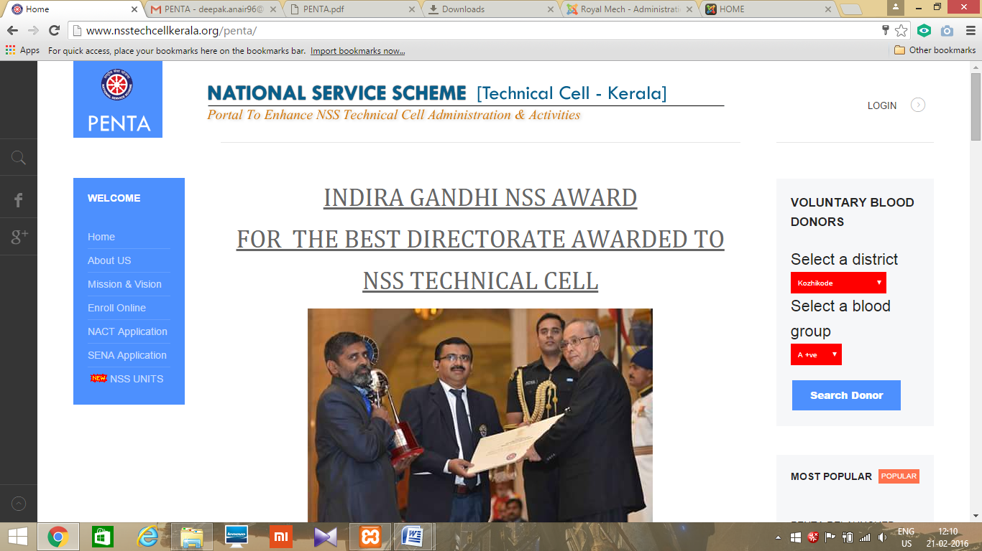

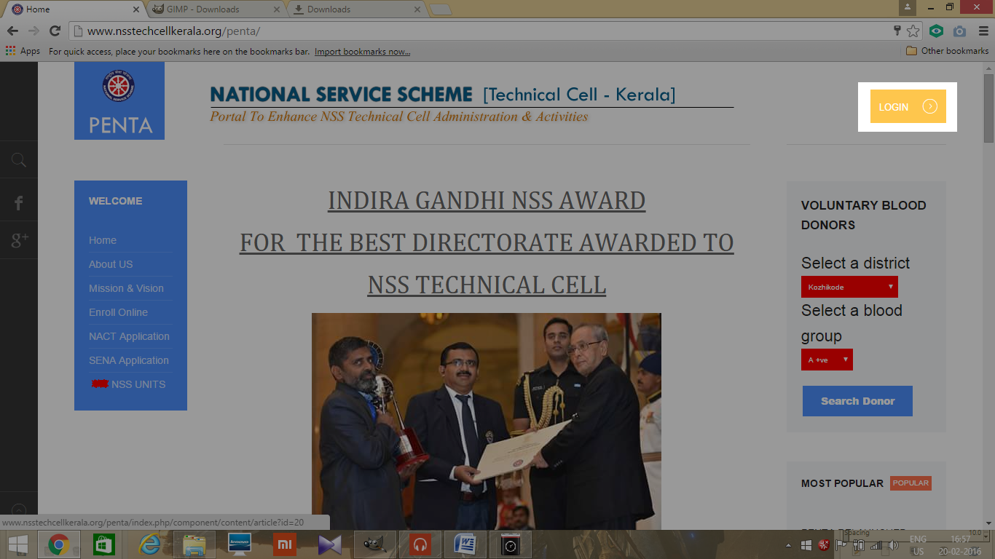
- Click LOGIN

- Then enter USERNAME and PASSWORD of PO and click login
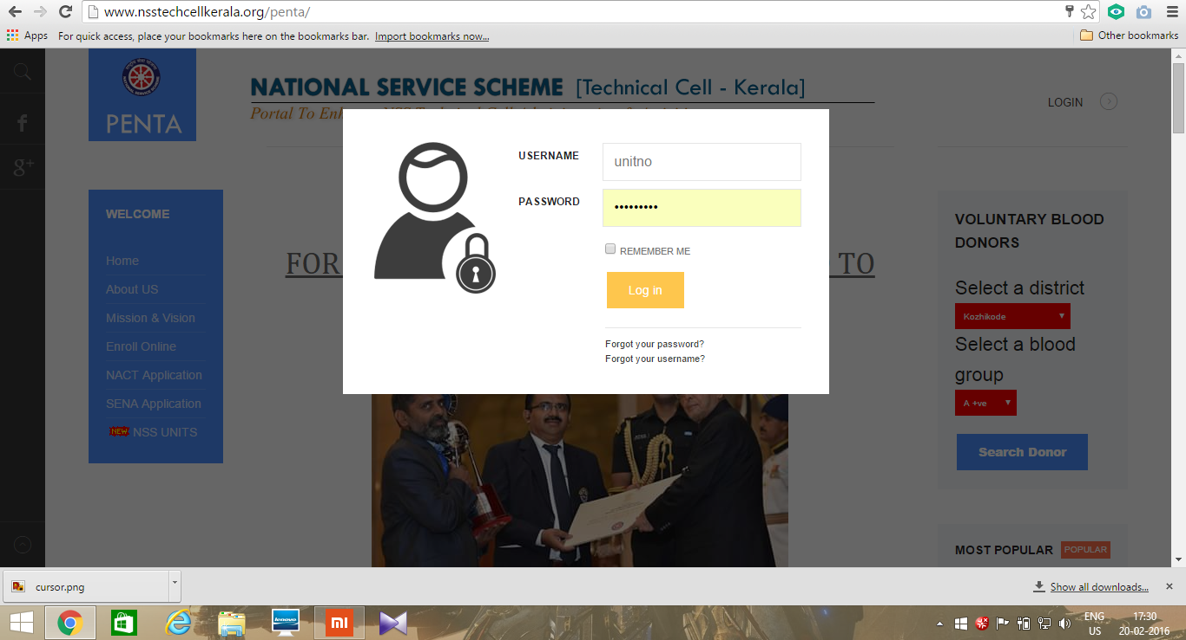

- Then the following dashboard will open
