PRINCIPAL APPROVAL

REVISION HISTORY
Date | Description | Author | VERSION
21/02/16 | USER MANUAL FOR PRINCIPAL APPROVAL | DEEPAK A NAIR | 1.0

PROGRESS FLOW OF CERTIFICATE GENARATION

LOGIN FOR PRINCIPAL
- Open Mozilla firefox/Google Chrome and type the address http://www.nsstechcellkerala.org/penta/ and press enter the following page will load.

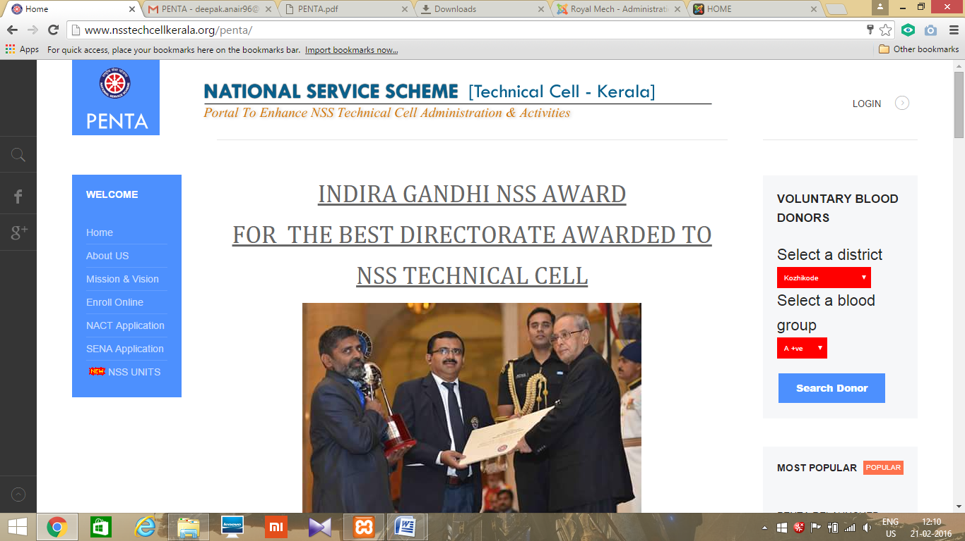

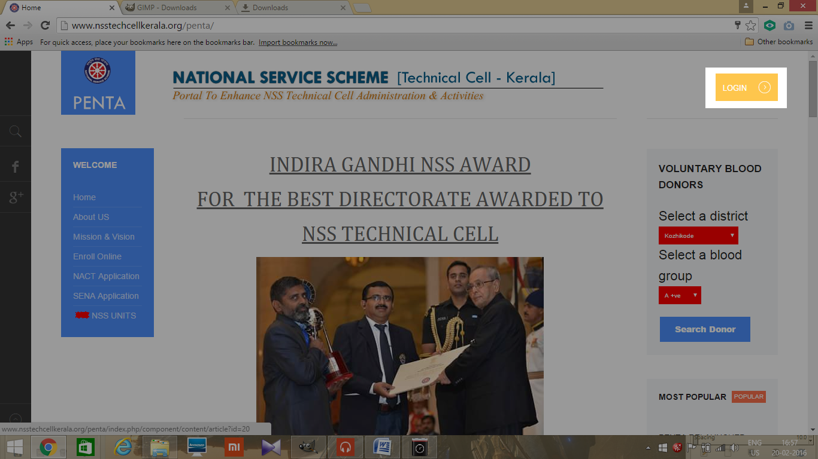
- Click LOGIN
- Then enter USERNAME and PASSWORD of PRINCIPAL and click login
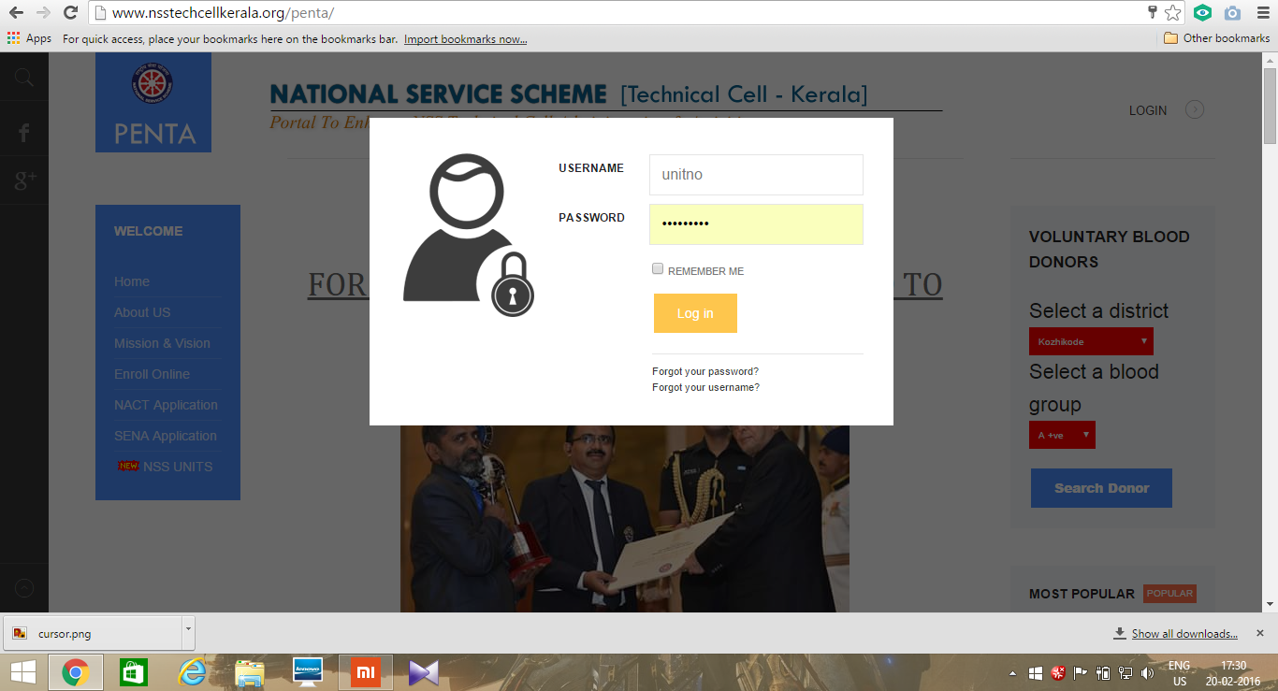

- Then the following dashboard will open
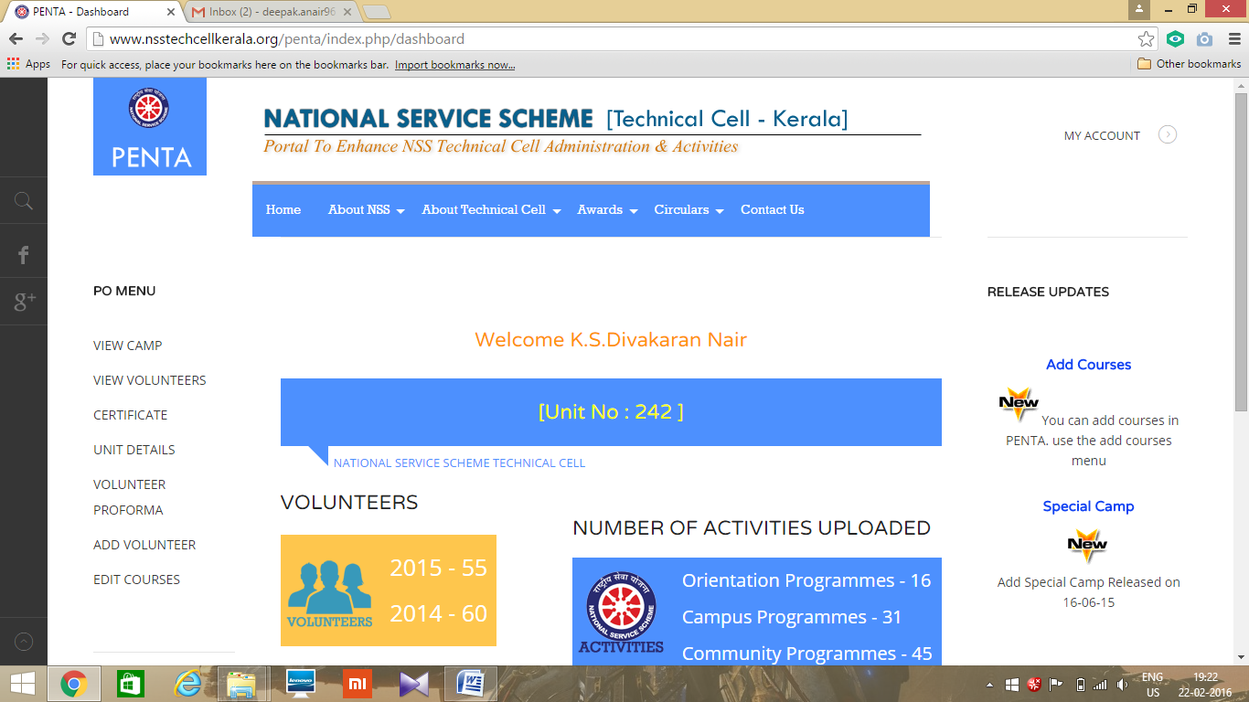

Principal approval
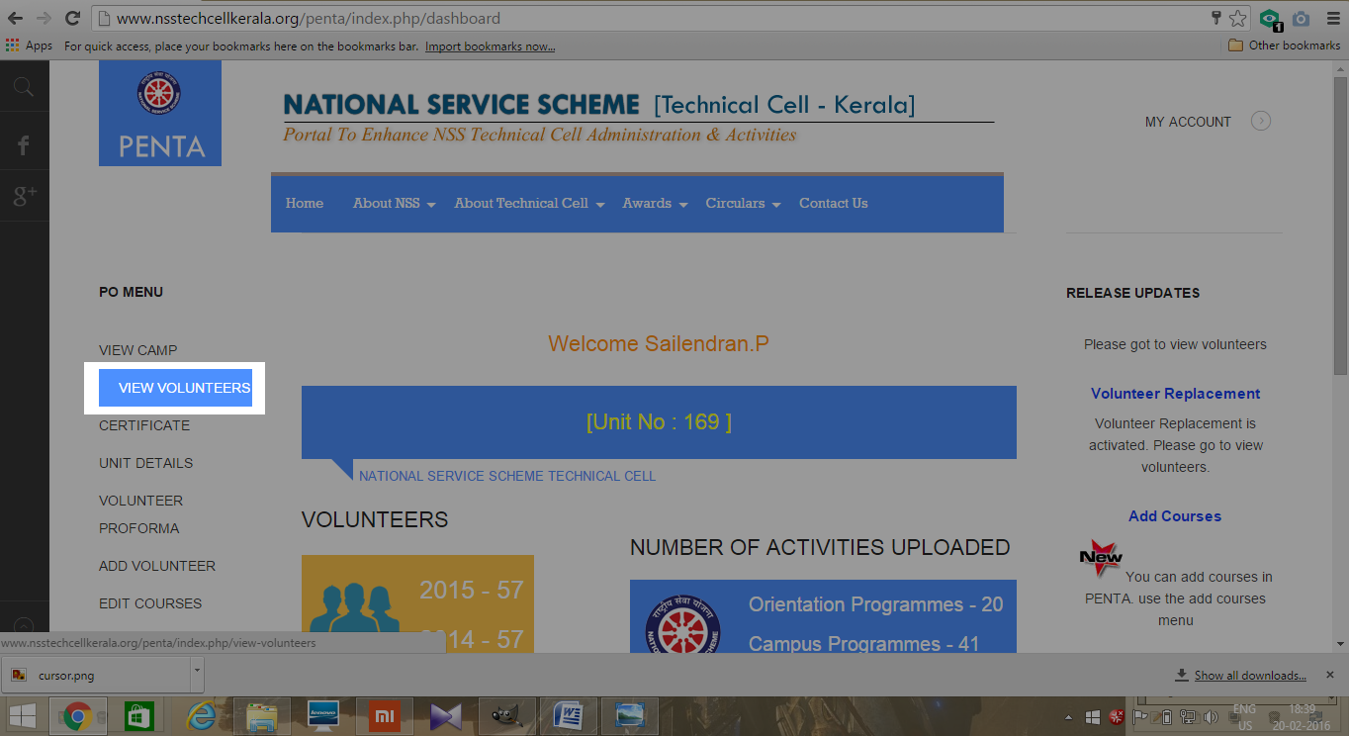
- Press VIEW VOLUNTEERS, after login

- Press arrow near status to see status of volunteer's
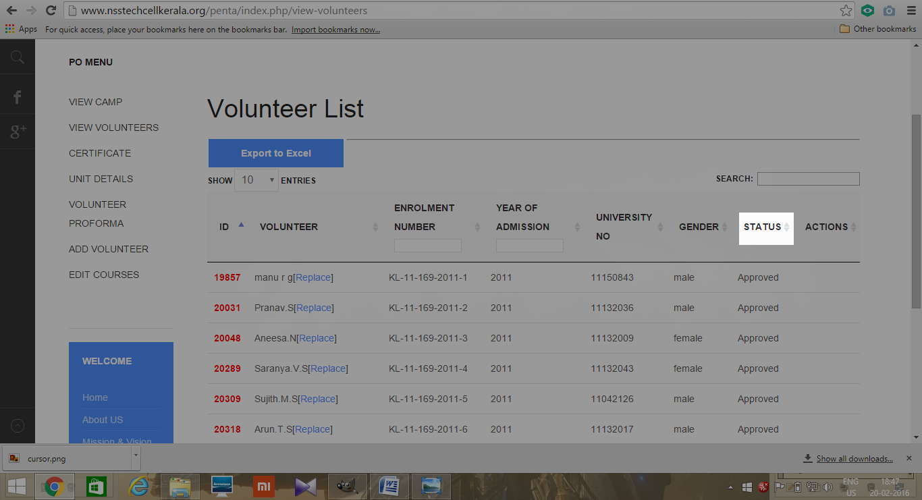

- Press approve to approve the volunteers
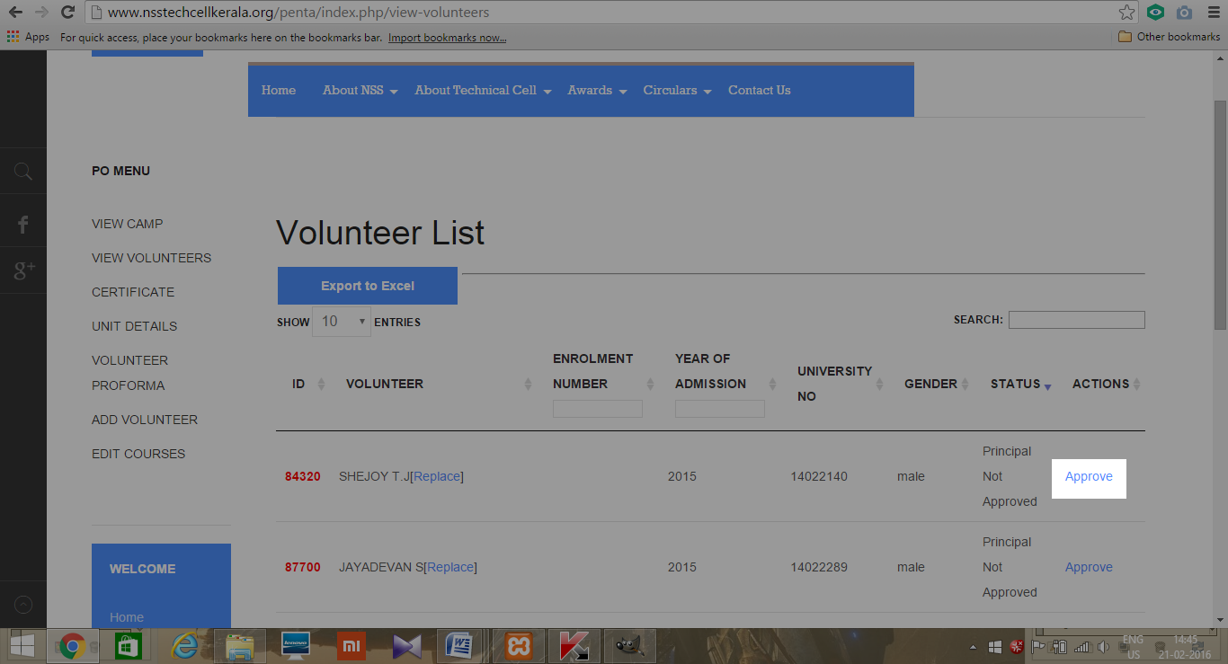

- A popup screen will appear press ok
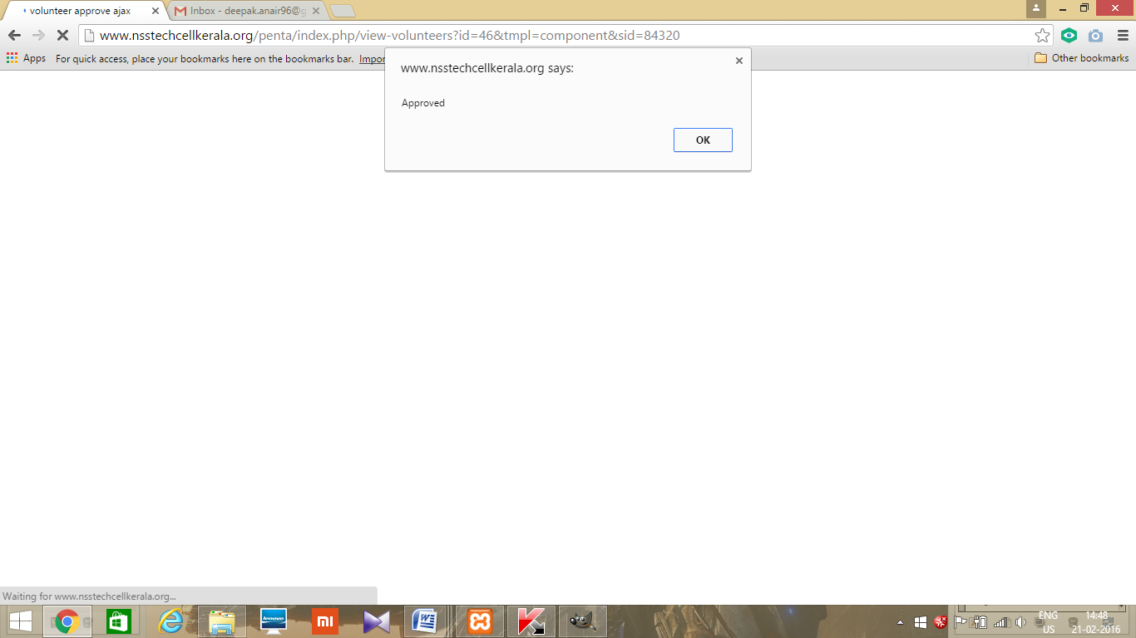
- It will show approved
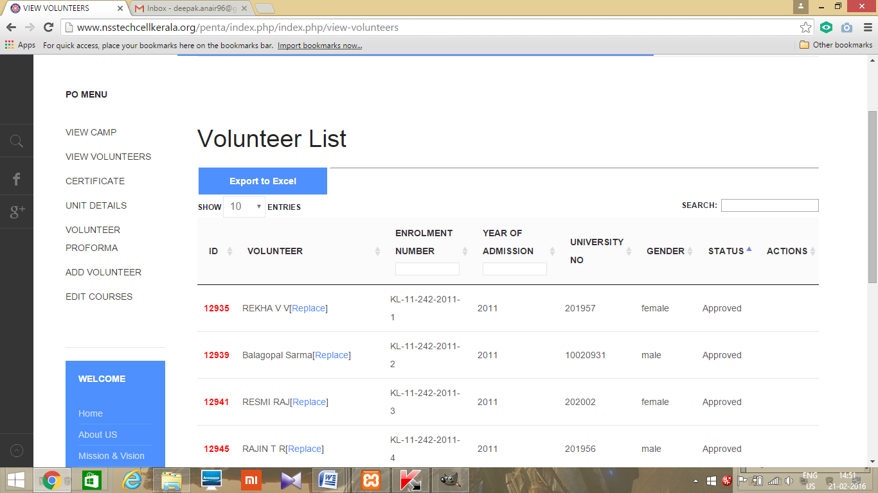

LOGOUT
- Click MY ACCOUNT on the top right corner.
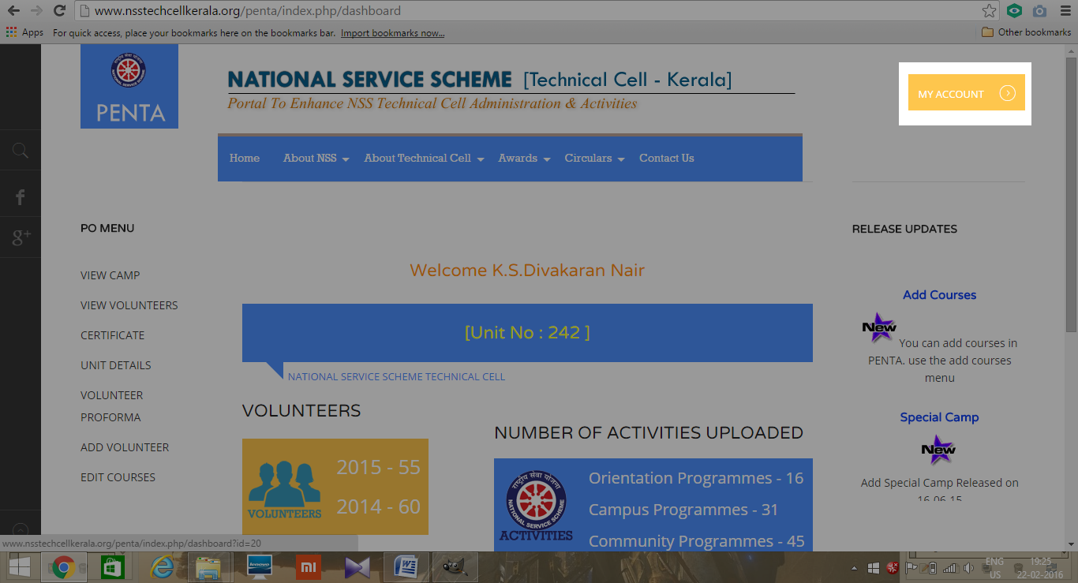
- Click logout.
