UNIT DETAILS

RIVISIONHISTORY
Date | Description | Author | Version
21/02/2016 | USER MANUAL FOR UNIT DETAILS | SHAMLIKHAN CP | 1.0

PROGRESS FLOW OF UNIT DETAILS

LOGIN FOR PO
- Open Mozilla firefox/Google Chrome and type the address http://www.nsstechcellkerala.org/penta/ and press enter the following page will load.

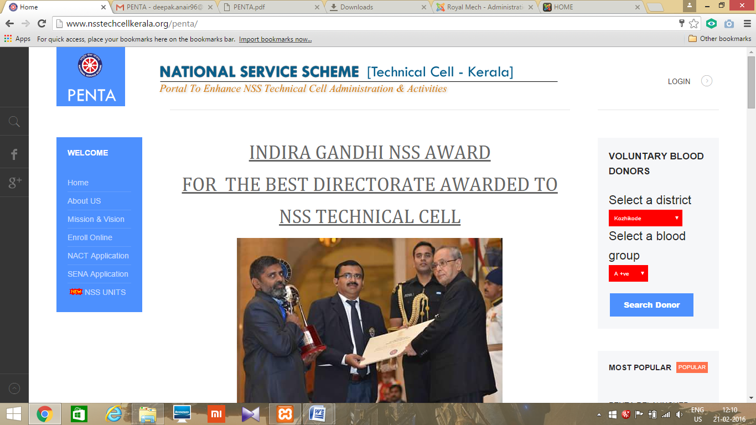

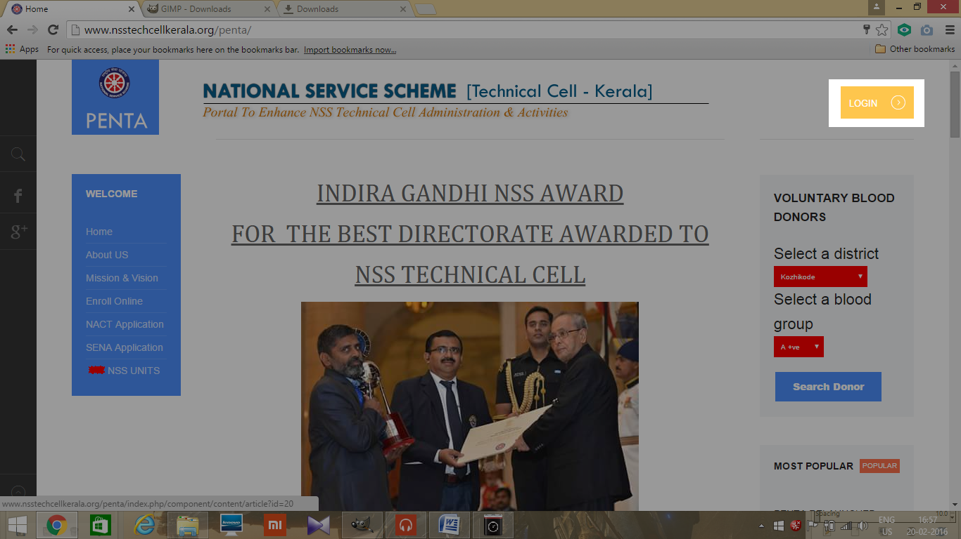
- Click LOGIN
- Then enter USERNAME and PASSWORD of PO and click login
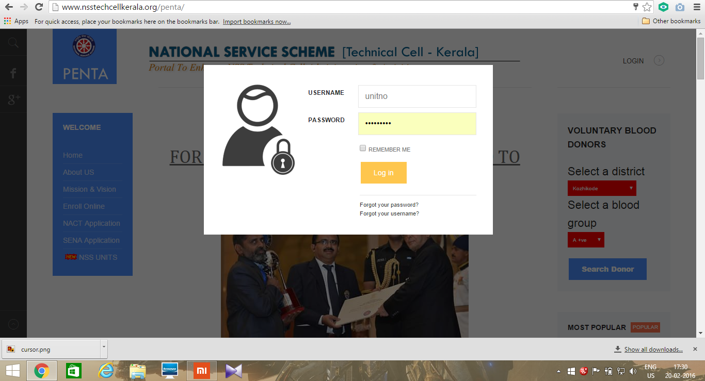

- Then the following dashboard will open
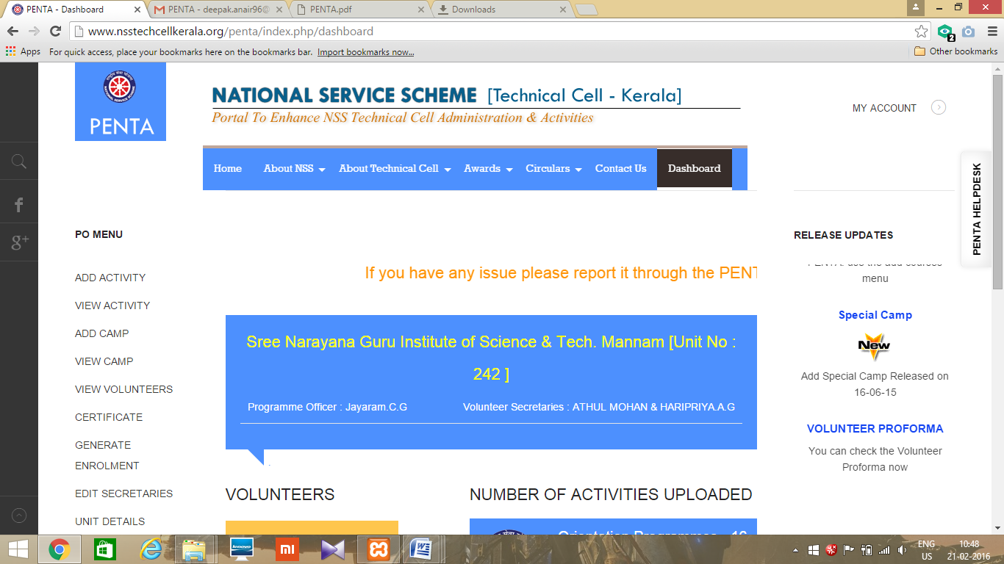

UNIT DETAILS

- After login, from the dashboard select the link UNIT DETAILS

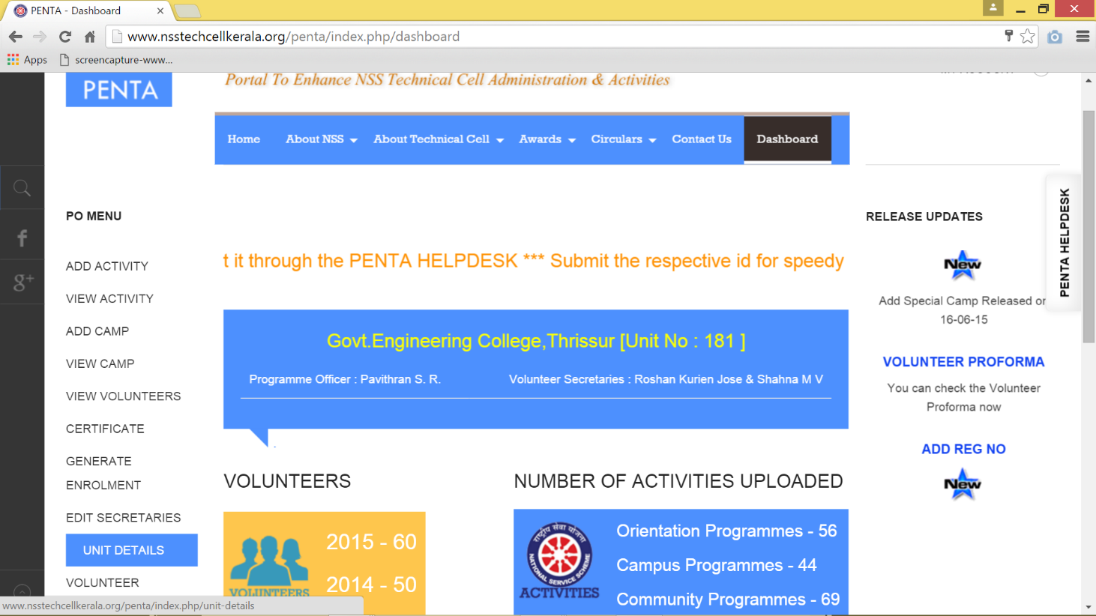

- You will be navigated to a webpage containing the unit details.

NOTE: You can’t edit the details from this view. To edit the details, please send a mail to teampenta@live.in or nsstechcellkerala@gmail.com

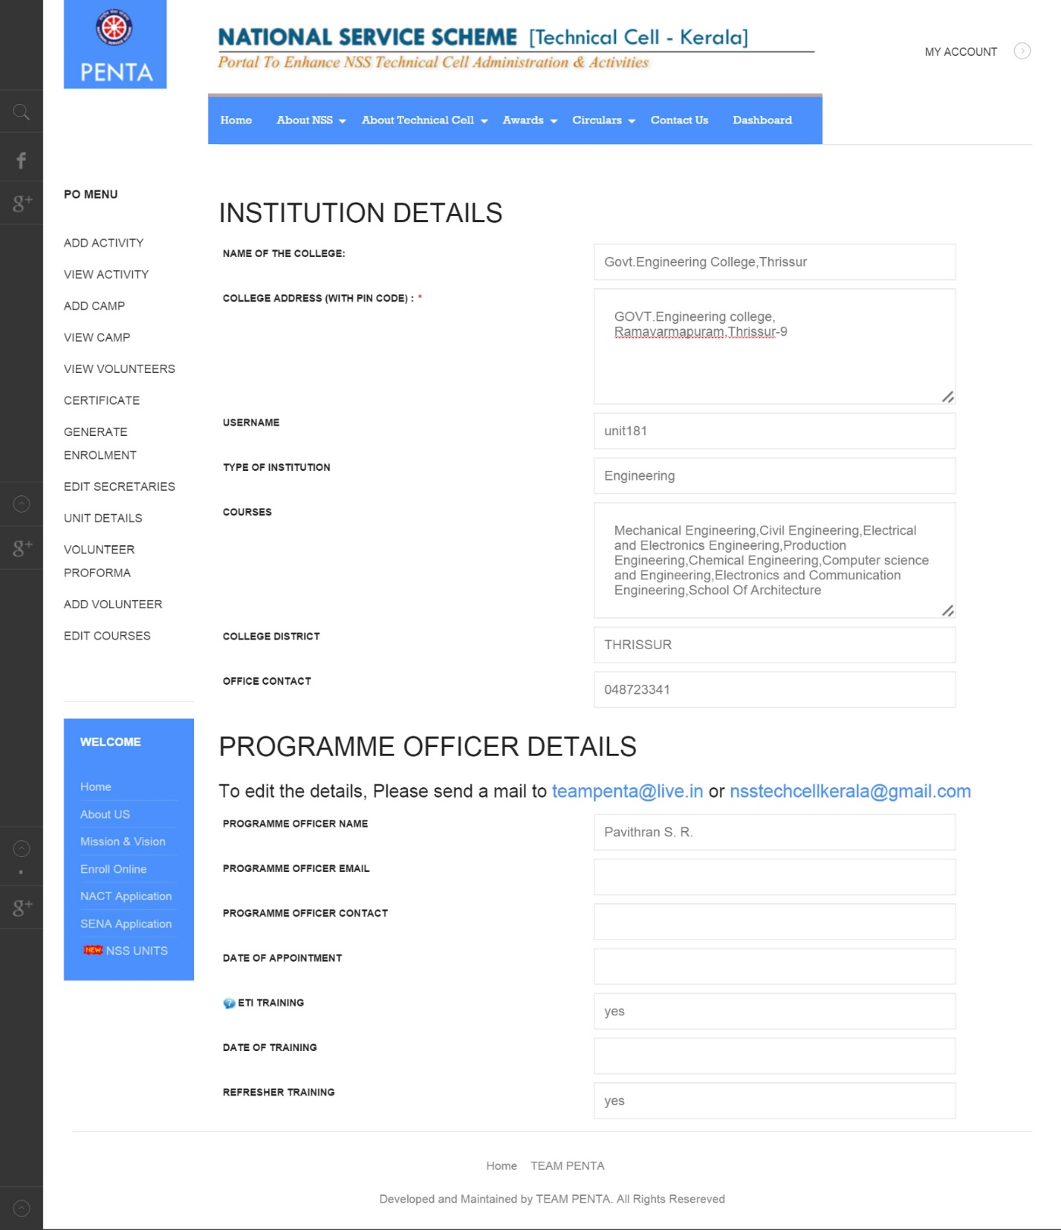

LOGOUT
- Click MY ACCOUNT on the top right corner.
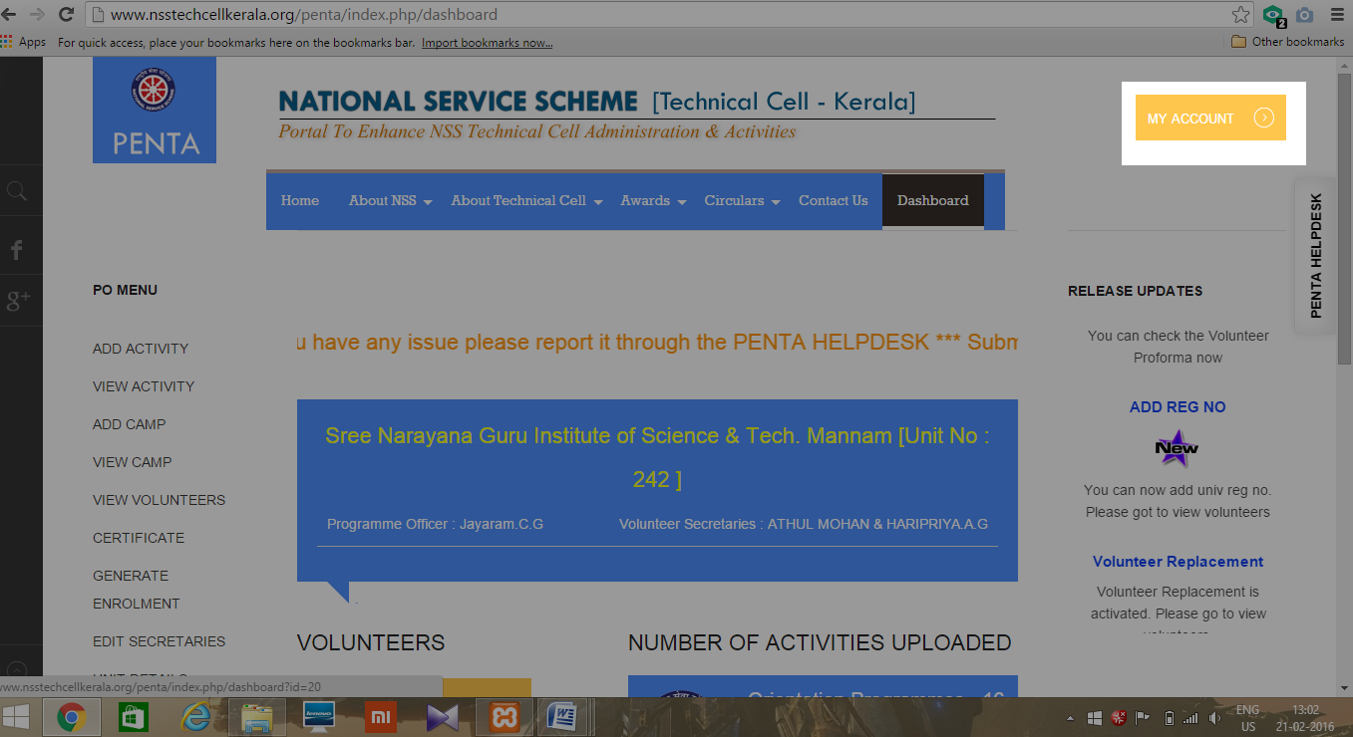
- Click LOGOUT
