VIEW ACTIVITY

PROGRESS FLOW OF VIEW ACTIVITY

REVISED HISTORY
Date | Description | Author | Version
21/02/2016 | USER MANUAL FOR VIEW ACTIVITY | Ananthu.s | 1.0

PO LOGIN

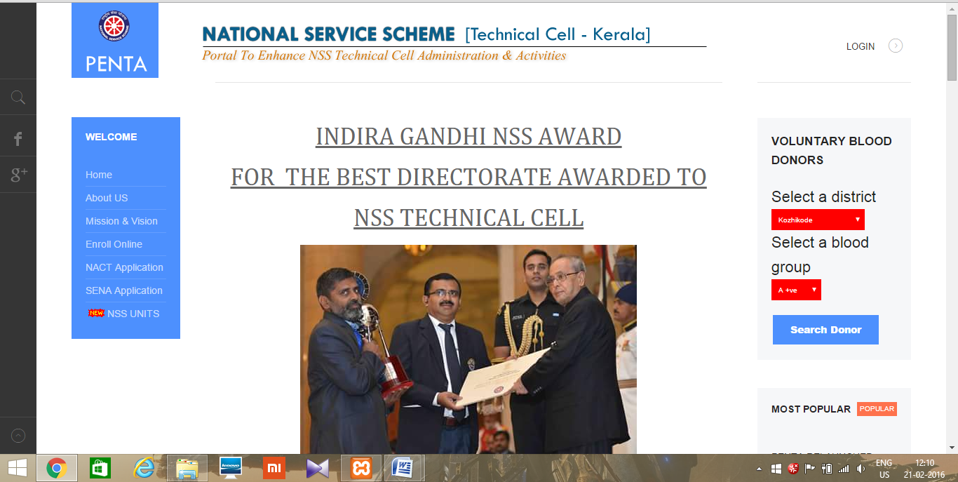
- Open Mozilla firefox/Google Chrome and type the address http://www.nsstechcellkerala.org/penta/ and press enter the following page will load.

- Click LOGIN
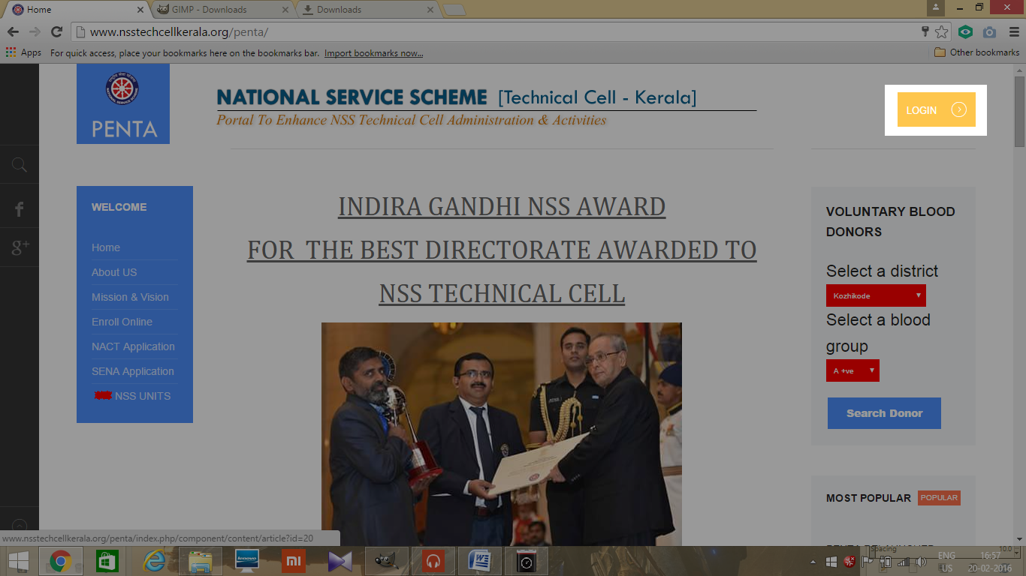
- Then enter USERNAME and PASSWORD of Programme officer
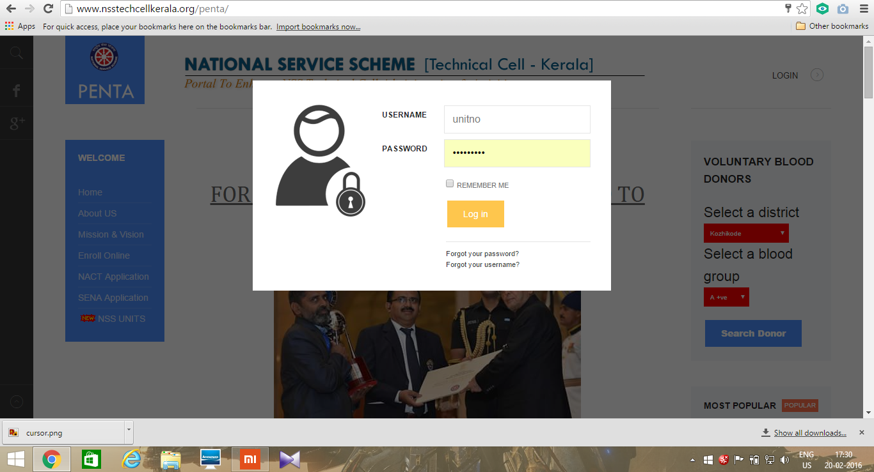

- Then the following dashboard will open
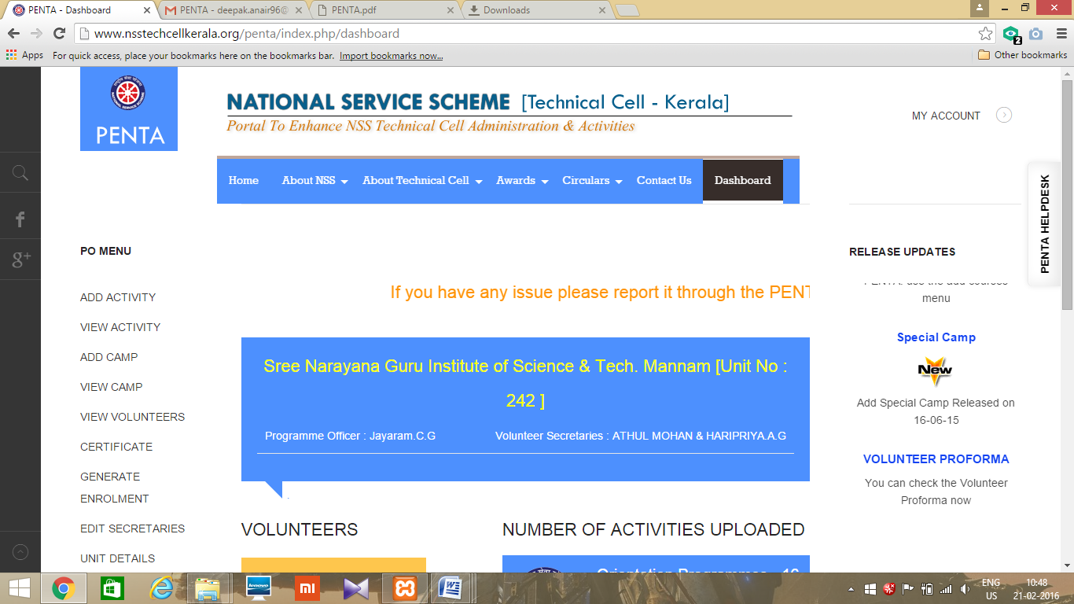

VIEW ACTIVITY

- After login, from the dashboard select the link VIEW ACTIVITY.
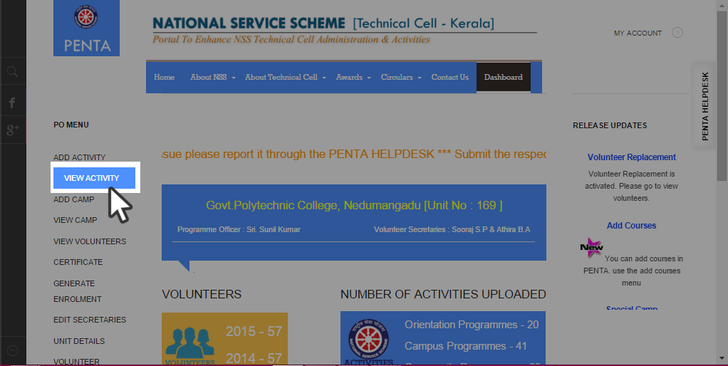
- Then appear a new window with the detailed list of uploaded activities.
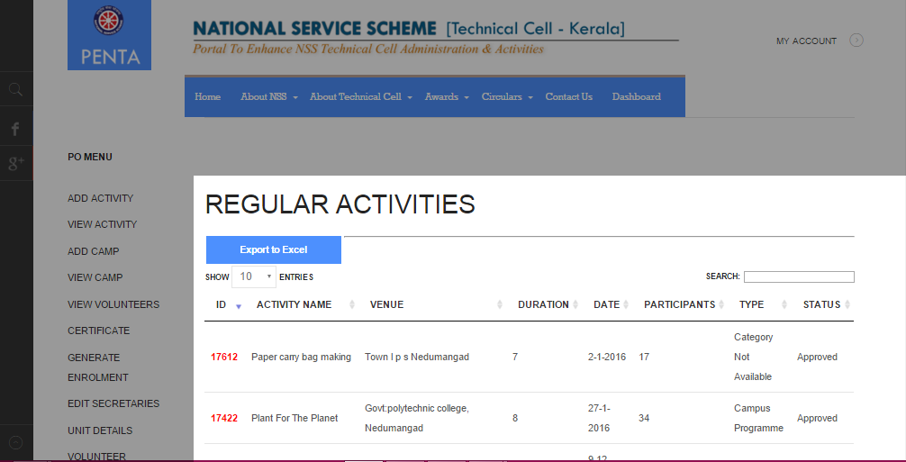

- From the appeared window we can see the unique ID of uploaded activity, Activity name, Venue, Duration, Date of activity, number of participants Activity type you are uploaded and the status of the activity (approved or not approved). And also you can search for uploaded activity and export the list into an Excel file using export to excel option with desired number of activity entries (10, 25, 50, and 100).

LOGOUT
- Click MY ACCOUNT on the top right corner.
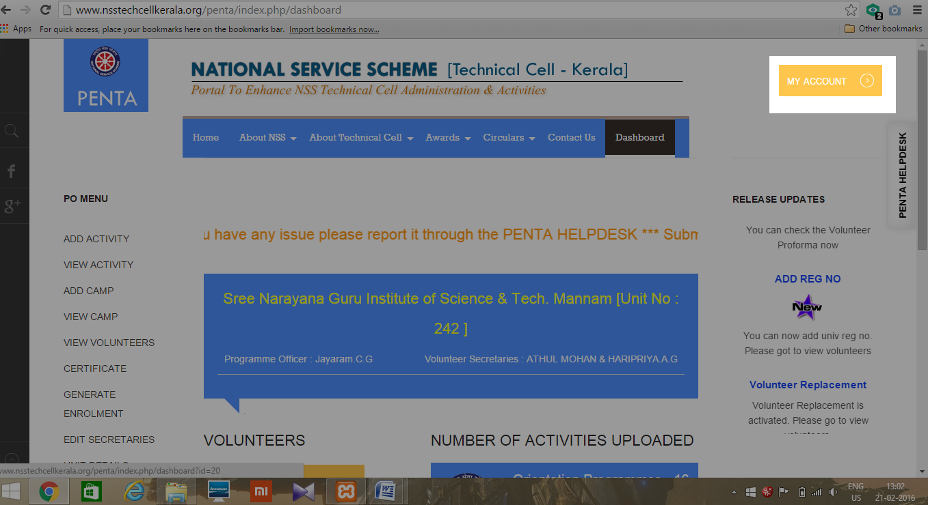
- Click LOGOUT.
